**RIGA TECHNICAL UNIVERSITY**

Faculty of Computer Science, Information Technology and Energy

**Alīna Žogota-Kiliča**

Student of Academic Master (Second Cycle) Study Programme “Digital Humanities”, student ID 241RHM001

**“IMPROVING AN ACADEMIC INFORMATION SYSTEM THROUGH COGNITIVE LOAD PRINCIPLES AND USER-CENTERED INFORMATION ARCHITECTURE: A CASE STUDY OF LUIS”**

**MASTER THESIS**

Scientific adviser RTU FCSITE docent

Ilze Andersone

Riga 2026

**RIGA TECHNICAL UNIVERSITY**  
**FACULTY OF COMPUTER SCIENCE, INFORMATION TECHNOLOGY AND ENERGY**

**Work Performance and Assessment Sheet of the Master thesis “Improving an Academic Information System through Cognitive Load Principles and User-Centered Information Architecture: A Case Study of LUIS”**

The author of the graduation thesis

Student Alīna Žogota-Kiliča_________________________________________________

(signature, date)

The graduation thesis has been approved for the defense

Scientific adviser

Scientific adviser RTU FCSITE docent, Ilze Andersone___________________________

(signature, date)

**Declaration of Academic Integrity**

I declare that this work is my own and does not contain any unacknowledged work from any source.

Signature__________________

Date______________________

**ABSTRACT**

Keywords: cognitive load, usability, information architecture, academic systems, user-centered design

This master’s thesis “Improving an Academic Information System through Cognitive Load Principles and User-Centered Information Architecture: A Case Study of LUIS” examines how cognitive load theory and information architecture principles can improve the usability of academic information systems in Latvia. The study focuses on how workflow structure, navigation, and interface clarity affect user mental effort and task performance.

The research follows a structured analytical pipeline that combines quantitative usability data from 92 LUIS users with supporting natural language processing methods for open-text feedback. The analysis distinguishes between intrinsic task difficulty and extraneous interface-related effort to identify the main sources of usability problems. The results show that most user difficulties are caused not by task complexity but by unclear terminology, fragmented navigation, hidden interface elements, and delayed system feedback.

Based on these findings, the thesis selects two high-impact workflows for redesigning and develops redesigned solutions for both student and administrative use cases. These workflows are tested with interactive prototypes on 51 LUIS users. The evaluation shows improved clarity, reduced perceived mental effort, and more efficient workflow completion compared to the current LUIS version.

The thesis contributes a replicable methodological framework for analyzing and redesigning academic information systems and provides practical information-architecture recommendations for future national study-process platforms in Latvia.

The total volume of the thesis is ___ pages, including ___ figures, ___ tables, ___ appendices, and ___ sources.

**ANOTĀCIJA**

Atslēgvārdi: kognitīvā slodze, lietojamība, informācijas arhitektūra, akadēmiskās sistēmas, lietotājcentrēts dizains

Šis maģistra darbs “Akadēmiskās informācijas sistēmas uzlabošana, izmantojot kognitīvās slodzes principus un lietotājcentrētu informācijas arhitektūru: LUIS gadījuma izpēte” analizē, kā kognitīvās slodzes un informācijas arhitektūras principi var tikt izmantoti akadēmisko informācijas sistēmu lietojamības uzlabošanai Latvijā. Pētījumā aplūkots, kā lietotāji uztver uzdevumu grūtību, kā saskarnes struktūra ietekmē mentālo piepūli un kā šos secinājumus var izmantot praktiskā darba plūsmu pārveidē.

Pētījumā izmantota strukturēta analītiskā pieeja, kas apvieno kvantitatīvus lietojamības datus no 92 LUIS lietotājiem ar dabiskās valodas apstrādes metodēm brīvo komentāru analīzei. Šī pieeja ļauj identificēt prioritārās darba plūsmas, galvenos saskarnes radītās slodzes avotus un biežākās lietojamības problēmas dažādās lietotāju grupās.

Rezultāti rāda, ka galvenās problēmas rodas no navigācijas struktūras, neskaidras terminoloģijas, slēptiem saskarnes elementiem un fragmentētām vairāku soļu darba plūsmām, nevis no pašu uzdevumu sarežģītības. Balstoties uz šiem secinājumiem, tika izstrādāti uzlaboti dizaina risinājumi prioritārajām studentu un administratoru darba plūsmām un pārbaudīti prototipu testēšanā ar 51 LUIS lietotāju. Testēšanas rezultāti uzrāda augstāku skaidrību, mazāku mentālo piepūli un labāku lietošanas ērtumu salīdzinājumā ar esošo LUIS versiju.

Darbs piedāvā atkārtojamu metodoloģisku ietvaru akadēmisko sistēmu darba plūsmu analīzei un uzlabošanai, kā arī sniedz praktiskus ieteikumus nākotnes nacionālo platformu attīstībai.

Darba kopējais apjoms ir ___ lappuses, tajā iekļauti ___ attēli, ___ tabulas, ___ pielikumi un ___ izmantotie avoti.

**TABLE OF CONTENTS**

INTRODUCTION 8

1. Theoretical Framework and Context 12

1.1. Digital Humanities and Academic Information Systems 12

1.2. Cognitive Load Theory for Digital Workflows 12

1.2.1. Intrinsic and Extraneous Load 12

1.2.2. Split-Attention Effect in Interface Design 12

1.3. User-Centered Design and Information Architecture 12

1.4. Big Data Concepts and NLP Methods 12

1.5. National Education Digitalization Policies 12

1.6. Academic Information Systems in Latvia 12

1.6.1. LUIS as a Case Study 12

1.6.2. Gaps in Existing Research 12

1.7. Integrated Framework for This Thesis 12

Chapter Summary 12

2. Analytical FRAMEWORK and Methods 12

2.1. Research Methods 12

2.2. Methodological Pipeline for Academic System Redesign 13

2.3. Data Collection and Sampling 15

2.4. Data Preparation 17

2.4.1. Quantitative Analysis Methods 18

2.4.2. NLP-Based Analysis Methods 18

2.5. Linking Findings to Cognitive Load and IA 20

Chapter Summary 21

3. PRACTICAL PART i: analytical groundwork results 23

3.1. Data Processing Results 23

3.1.1. Summary of Quantitative Findings 31

3.2. NLP Analysis Results 31

3.3. Summary of analytical findings 38

3.4. Workflow Selection for Practical Part 39

Chapter Summary 40

4. Practical Part II: UX Case Study 42

4.1. Design Principles Derived from Analysis 42

4.2. Selected Workflows & Existing Problems 42

4.3. Redesign Strategy 48

4.4. Low-Fidelity Wireframes 51

4.4.1. Low-Fi: Mobile Course Registration 52

4.4.2. Low-Fi: Desktop Course Registration 53

4.4.3. Low-Fi: Grade Entry (Admin) 54

4.5. Prototype Development and Testing 55

4.6. Prototype Testing Results 56

4.7. UI Design Style Guide 61

4.7.1. High-Fidelity Design Proposal 64

4.8. Future Work 66

Chapter Summary 66

Discussion 68

CONCLUSION 70

LIST OF REFERENCES 73

APPENDICES 78

ABBREVIATIONS 89

INTRODUCTION

This master’s thesis “Improving an Academic Information System through Cognitive Load Principles and User-Centered Information Architecture: A Case Study of LUIS” examines how usability problems in Latvian academic information systems can be reduced by improving information structure and lowering unnecessary cognitive effort. The Latvian Academic Information System (LUIS) is one of the main platforms used by higher education institutions for enrolment, course registration, grade tracking and reporting. Although it supports daily academic and administrative tasks, users often report issues with navigation, unclear terminology, slow feedback and visual inconsistency. These problems reduce productivity and cause frustration. As higher education becomes more digital, the usability of these systems becomes an important topic.

In Latvia, academic data is managed across several separate platforms, including the State Education Information System (VIIS), the University of Latvia’s LUIS, and Riga Technical University’s ORTUS. Because these systems were developed independently, their functions overlap and the user experience is fragmented. According to recent decisions by the Ministry of Education and Science and the Ministry for Environmental Protection and Regional Development, these systems will be gradually unified under a new national architecture (IZM, 2025; VARAM, 2025). LUIS will therefore be replaced or merged with this new platform. However, it is operational today and remains foundational for daily academic tasks, and its issues affect users. Studying LUIS now provides a real case for understanding user needs and creates input that can guide future system development. Researching user-experience principles and psychology-informed user flows can provide short-term improvements for the present system and form a knowledge base for future national platforms.

The novelty of this research lies in its interdisciplinary focus, combining user-centered design, information architecture, and cognitive-load principles to examine a national academic information system. In the Latvian higher education context, few studies analyze academic platforms from this perspective. Cognitive principles help explain how workflow structure, navigation complexity, and visual noise influence user attention and mental load, while information architecture and interface design offer ways to reduce this effort by improving clarity, grouping, and structure. By combining these perspectives with user data and automated text analysis, this thesis develops practical, data-supported redesign proposals that make academic systems easier to use. Although the current dataset is modest in size, NLP is included because future national systems will generate large volumes of open-text feedback, and a scalable, automated analysis method is therefore required in the proposed framework.

The two goals of this research are:

1. Develop a replicable methodological framework for analyzing and redesigning academic information systems. This includes survey structuring, systematic data processing, thematic and NLP-based analysis, workflow examination, and the integration of cognitive load and information architecture principles into design decisions.
2. To apply and validate this method to the LUIS system to produce practical redesign recommendations for high-impact student and administrative workflows.

To achieve these aims, the following tasks were set:

1. Analyze relevant literature and national digitalization policies to establish the theoretical and institutional context for improving academic information systems.
2. Develop the methodological framework by outlining the full analytical pipeline that will later serve as a replicable approach for academic information system redesign.
3. Identify usability issues through a user survey, focusing on cognitive load, navigation friction, terminology, workflow clarity, and device-based differences.
4. Process and analyze survey data using descriptive statistics, priority scoring, correlation analysis, and NLP methods to reveal recurring patterns in user experience.
5. Select high-load and high-impact workflows for redesign, based on combined statistical, qualitative, and NLP indicators.
6. Develop low-fidelity prototypes and high-fidelity visual proposals, following cognitive load principles and information architecture rules defined in the methodological framework.
7. Assess redesigned workflows with users, collecting task-based metrics and short cognitive-load assessments.
8. Evaluate results and interpret implications, connecting user testing outcomes back to the methodological framework to validate the approach and refine the redesign recommendations.
9. Compare the number of workflow steps before and after redesign to quantify structural improvement and reduction in cognitive load.

The hypothesis is that usability problems in LUIS come from structural design rather than task complexity, and that improving information architecture based on cognitive load principles will lead to higher clarity, lower mental effort and easier workflows.

The object of the research is the Latvian Academic Information System (LUIS), and the subject is academic information systems usability improvement through user-centered information architecture and cognitive-load principles.

The research question is: How can user-centered information architecture, informed by cognitive-load principles, improve the usability of academic information systems, and what does the case of LUIS show about reducing unnecessary mental effort in such platforms?

This thesis uses mixed methods. Qualitative work includes heuristic observation of workflows. Quantitative work includes surveys with Likert scales, usability scoring, and descriptive statistics. NLP methods are used to analyze open-text feedback. Data was collected between April 2024 and November 2025, and the analysis and testing were completed within that period. User data analysis is used as a supporting tool to identify priorities for interface improvement. In this research, data analysis is not a method of system improvement itself but serves to understand user behavior and evaluate the effects of proposed design changes. The actual improvements are guided by cognitive principles, user-centered design, and interface-design practices.

The main limitation is the lack of access to LUIS system logs, which prevents deeper statistical analysis of user behaviour. Because of this, the research relies on observable workflows, self-reported feedback, and the author’s practical experience in daily academic administration. Another limitation is the scope: the study focuses on small, targeted usability improvements rather than full system redesign. Reliability and validity are supported through triangulation of survey data, standard usability principles, and transparent interpretation of results. The framework is designed to remain scalable so that institutions can reuse the same steps when larger datasets or log-based analytics become available.

The thesis is organized into three chapters that reflect the development of the methodological framework and its application: First chapter presents the theoretical foundations: cognitive load, information architecture, user-centered design, and national digitalization context. Second chapter presents the methodological framework and analytical pipeline, including survey design, quantitative processing, NLP analysis, and workflow-selection logic. Third chapter applies the framework to LUIS. The practical part is divided into two connected sections: Part I: analytical groundwork and workflow selection. Part II: redesign and user testing of selected workflows. The chapter presents the original and redesigned workflows, testing outcomes, and a comparison of workflow structure and cognitive load before and after redesign. Appendices include the survey instrument, data-processing code, prototype screenshots, and supporting visualizations.

In conclusion, this research shows how cognitive-load principles and interface-design methods can improve the usability of academic information systems in Latvia, using LUIS as an example. The study offers practical, user-centered recommendations supported by user data. These insights can help improve the current system and guide the design of future national academic platforms planned under Latvia’s digitalization strategy.

# Theoretical Framework and Context

This chapter provides the theoretical foundations that support the methodological framework developed in Chapter Two. It introduces the core concepts - Digital Humanities, cognitive load, user-centered design, information architecture, accessibility, Big Data and NLP - that later guide how usability problems are analyzed and how redesign decisions are made.

## Digital Humanities and Academic Information Systems

Digital Humanities (DH) brings together humanities, social sciences, and computing to study how digital tools shape communication, knowledge, and everyday practices. Recent DH studies highlight that the field is no longer limited to text analysis or cultural archives. It also examines the systems, platforms, and infrastructures that organize information and structure institutional life (Berry & Fagerjord, 2017; Schreibman et al., 2016). In this sense, DH provides a useful lens for analyzing digital systems not only as technical tools but also as cultural and organizational artefacts.

Academic information systems such as VIIS and LUIS can also be treated as DH artefacts. They organize educational data, structure workflows, and shape how students and staff interact with academic processes. They are sociotechnical systems- part technical, part institutional- and they reflect decisions about design, policy, and communication. Research in education technology and digital governance shows that these systems influence academic participation and everyday work practices (Persico & Pozzi, 2015). For this thesis, treating LUIS as a DH artefact helps connect user behaviour, cognitive effort, and design choices with broader questions of digital transformation in higher education.

This conceptual link also explains why methods from UX research, information architecture, cognitive psychology, and basic NLP belong in a DH project. They support the study of how people engage with digital systems, how information is structured, and how complexity affects users. DH encourages this interdisciplinary approach, combining human-centered analysis with technical methods to understand interaction patterns and improve digital tools. This supports the overall aim of the thesis: to analyze usability problems in LUIS and propose design improvements grounded in psychology, interface design, and user feedback.

These ideas form the conceptual bridge to the methodological steps outlined in Chapter Two, where DH principles guide how LUIS is analysed as a sociotechnical system rather than only an interface.

## Cognitive Load Theory for Digital Workflows

Cognitive Load Theory (Sweller, 2011) explains how the human brain processes information when performing tasks. It states that people have a limited working memory, which can handle only a few elements at the same time. When a digital system shows too much information at once or presents it in a confusing way, the user becomes overloaded and makes more mistakes. The theory divides mental effort into three parts: intrinsic, extraneous, and germane load. Intrinsic load depends on how difficult the task is. Extraneous load comes from poor design or unclear instructions. Germane load is the useful effort that helps users understand and remember what they do. In the context of LUIS, this theory helps explain why many users experience frustration and slower work. The interface requires too many steps, unclear labels, and separate screens for related actions. These design problems increase extraneous load and make simple actions difficult. A good design should focus on reducing unnecessary steps and keeping attention on the main goal. The aim is not to make the system simpler in function, but clearer in use (Sweller, 2011). This connection between cognitive effort and design efficiency makes Sweller’s theory highly relevant for usability testing in this research.

(Ouwehand et al., 2025) look at how Cognitive Load Theory (CLT) is changing in today’s digital and online learning environments. They argue that the three main types of cognitive load, extraneous, and germane, remain important, but new factors are emerging due to technology. For example, interactive features, rich visuals, and immersive interfaces may either help users learn or increase unnecessary mental effort depending on how well they are designed. In the context of systems like LUIS, this means design choices must go beyond just making tasks simpler. They must consider how the digital environment (screens, menus, animations) affects how much thinking users spend on how to use the system rather than what they need to do. Reducing extraneous load and directing germane load toward meaningful tasks supports better usability and user satisfaction.

(Marek Pałys, 2024) explains that cognitive psychology helps us understand how people think, remember and make decisions, and these insights are very useful for user experience (UX) design. He shows that designers can use ideas like the limits of working memory, how people automatically group visual items (Gestalt), and common decision-making shortcuts to create better interfaces. For example, when users see menus arranged by similarity or proximity, they understand faster because of the Gestalt principles (Marek Pałys, 2024). Pałys also emphasises the idea of cognitive load, meaning how much mental effort a user expends when using a system. He argues that good UX design reduces unnecessary mental effort so users can focus on what matters, not just how the system works (Marek Pałys, 2024). These ideas apply to a system like LUIS: by organising menus clearly, using consistent icons and colours, and simplifying user steps, we help students and staff use them with less struggle and more confidence.

(Alasmari, 2020) explored how screen size affects students’ cognitive load in mobile learning settings and found that smaller displays sometimes led to lower mental effort. The research suggests that when users work on smaller screens, their interface should be simplified so less brain power is spent navigating the system and more can be devoted to the task (Alasmari, 2020). For a system like LUIS, which many users access from different devices, this means the design should be responsive and optimized for smaller screens. Buttons must stay large enough, menus must remain visible, and workflows should avoid complex layout shifts. Attention to device context supports your broader goal of improving usability through visual design and psychology.

This perspective becomes central in the analytical framework, where intrinsic and extraneous load are measured and later used as criteria for selecting workflows for redesign.

* + 1. Intrinsic and Extraneous Load

(Leppink et al., 2013) developed a questionnaire to measure before mentioned three types of cognitive load: intrinsic load (how hard the task is), extraneous load (how much extra work the system or interface causes), and germane load (how much effort supports learning or task performance). They tested the instrument in several student groups and confirmed the three-part structure. This is important because it gives researchers a simple way to separate the load that comes from the task itself from the load caused by poor interface design or unclear workflow (Leppink et al., 2013). For a system like LUIS, this distinction is useful. It allows the researcher to design a usability test that targets intrinsic and extraneous load specifically. For example: how much mental effort is spent because the task itself is complex? And how much extra effort is caused by unclear navigation or terminology? This research does not explore germane load, as the focus is on completing administrative workflows, not on learning new concepts. Using this framework will support a more focused and measurable analysis of interface challenges.

(Darejeh et al., 2024) analyze 76 studies that measure cognitive load in different digital environments, such as web systems, mobile apps, and virtual reality. They explain that there is no single perfect way to measure cognitive load because each method has strengths and limits. The most common tools are subjective scales, such as NASA-TLX or Paas’ mental effort scale, where users rate how hard they felt the task was. Other studies use performance data, like task time and error counts, or physiological measures, such as eye-tracking or heart rate. The authors recommend choosing a method that matches the goal of the test and the resources available (Darejeh et al., 2024). For a system like LUIS, cognitive load can be measured through short surveys right after users complete specific tasks. These surveys can ask users to rate how mentally demanding, confusing, or frustrating the task felt. This method is simple, non-invasive, and works well with qualitative observations. When combined with task completion time and small notes on where users hesitate, it gives a good picture of which parts of the interface create unnecessary effort.

(Faudzi et al., 2024) studied how mobile learning application design affects users’ cognitive load: the amount of mental effort needed to use an interface. They found that confusing layouts, too many colors, or inconsistent navigation cause users to spend energy figuring out how to use the system instead of focusing on the content. The study introduced a way to measure this “extra” mental effort and confirmed that simple and consistent designs reduce it. For systems like LUIS, this means usability depends not only on features but also on how the interface supports clear thinking. When the design is visually clean, the layout predictable, and the feedback immediate, users make fewer mistakes and feel less stress. This research supports the idea that improving LUIS usability should focus on lowering cognitive load through thoughtful visual and structural design.

(Skulmowski & Xu, 2022) explain that digital and online systems can create extra mental effort for users, called extraneous cognitive load. This happens when people must spend time figuring out how to use the interface instead of focusing on their main task. For example, too many visuals, moving elements, or complex menus can distract users instead of helping them. The authors point out that visual and interactive features should only be added when they serve a clear purpose, such as guiding attention or improving understanding. For systems like LUIS, this means that design should support users in finishing tasks with as little unnecessary effort as possible. Every color, animation, or button should have a clear role. A simple, predictable layout reduces cognitive load and helps users stay focused and confident while using the system.

These distinctions directly inform the survey structure and later the redesign criteria, as the practical part specifically targets reductions in extraneous cognitive load.

* + 1. Split-Attention Effect in Interface Design

(Cierniak et al., 2009) studied how the way information is presented influences people’s mental effort when they learn. They found that when users must divide their attention between separate sources, such as a diagram and a block of text, they must spend more time and effort integrating them. This is known as the “split-attention effect”. In interface design, the same principle applies: if a user must click between menus, pop-ups, and information panels, their cognitive load increases. For a system like Latvian academic information systems this means that interface elements should be grouped, aligned and visually coherent so users don’t waste effort on navigating rather than working. Clear layout, minimal duplication of information, and closely related visual-text combinations help reduce unnecessary mental load and improve usability.

(Xiao et al., 2024) explore the famous Fitts’ Law in modern interfaces: how long it takes users to move and select controls depends on size, distance, and design. They review versions of the law across devices and find that smaller targets, longer distances, or inconsistent layouts slow users down. They also show that when interfaces follow Fitts’ Law principles, large buttons, short paths, predictable placement, users perform actions faster and with fewer errors (Xiao et al., 2024). For a system like LUIS, this means design details such as button size, menu placement, and screen workflows matter a lot. If a frequently used function is placed far off, or keys are small on a mobile device, mental effort increases and performance drops. Applying Fitts’ Law in the prototype can help reduce “friction” in navigation and improve usability.

This set of principles later guides the interface decisions in the prototype design, especially around grouping, visual hierarchy, and reducing unnecessary attention shifts.

## User-Centered Design and Information Architecture

User-centered design builds on basic ideas from cognitive psychology, including limits of attention and memory (Marek Pałys, 2024; Sweller, 2011). It focuses on designing systems around real users, their skills, needs, and everyday habits, rather than around system logic.

(Puebla et al., 2022) studied how older adults (aged 60+) use mobile language-learning apps and found that many current systems don’t meet their needs. The authors followed a design-thinking process with 22 German-speaking older adults and built a prototype app that promoted social interaction, activity and practice opportunities. They found that older users valued apps that helped them learn together, stay active and use their interests, not just apps built for younger users. For an academic information system like LUIS, this means we must design with user groups who vary widely in tech-skills, physical ability and learning styles in mind. Simple layout, clear flow, social support features and visible feedback are especially important. The study supports the idea that usability design should be inclusively built from the start, not added as an afterthought.

Information architecture connects cognitive principles with system structure. When information is grouped clearly and workflows follow a logical order, users form quicker mental models and experience less unnecessary effort (Ghafur et al., 2025; Marek Pałys, 2024).

(Ghafur et al., 2025) applied process mining to student admission logs and discovered how administrative workflows often stall due to hand-offs, redundant approvals, and unclear task paths. Their work shows that when a system records detailed logs, we can map where time is lost and where design changes can simplify the flow. In the case of LUIS, this means it’s not only interface design that matters but also how workflows are structured under, clearer process paths and fewer manual steps reduce user frustration.

Navigation and visual hierarchy translate cognitive load ideas into interface decisions. Clear paths, consistent placement, and visible priorities help users focus on what they need to do instead of searching for controls (Faudzi et al., 2024; Xiao et al., 2024).

This forms the structural backbone of the redesign strategy in Chapter Three, where workflows are simplified and reorganised using IA rules derived here.

**Digital Accessibility and WCAG 2.2**

The Web Content Accessibility Guidelines 2.2 (W3C, 2024) provide clear instructions about how digital platforms should be designed so people with different disabilities can use them easily. The standard covers issues like how big and clear buttons should be, how keyboard navigation must work, and how the interface should remain predictable and understandable. For a system like LUIS, using WCAG 2.2 means checking that menu buttons are large enough, navigation works without a mouse, colors provide enough contrast, and that help options are always visible. Applying these guidelines supports not just usability but fair access to the platform for all users. WCAG principles later serve as an evaluative checklist in the redesign to support clarity, readability, and equitable access across devices.

## Big Data Concepts and NLP Methods

In this thesis, Python was used to organize and clean the data, create new variables, and prepare open-text comments for further analysis. This reflects the basic principles of working with unstructured data: standardise inputs, reduce noise, and extract recurring themes that support decision making. Although the dataset is small, the same logic used in larger Big Data contexts applies, value appears only after the data is structured, simplified, and connected to the research questions. NLP is included because future national platforms will collect large volumes of open-text feedback. Integrating NLP in the framework ensures that the method remains scalable and applicable beyond a small-sample research setting.

User feedback, logs, and open-ended survey responses are forms of unstructured data that require cleaning and structuring before they can support analysis. (Malviya & Malmgren, 2019) in Big Data for Managers note that unstructured text often contains the most valuable insights about user behaviour, but it must be standardised to reveal patterns. This applies to the LUIS usability dataset: users describe issues in different words, with varying detail and clarity, and these comments cannot be analyzed without pre-processing.

(Duarte Nancy, 2019) explains that data by itself rarely leads to action. What matters is how we tell the story behind the data. She shows that data should always be presented with empathy for the audience, focusing on what people need to understand and do next. In the case of systems like LUIS, this means presenting usability results in a way that clearly shows how they affect students and staff. Duarte introduces the idea of a “Data Point of View,” or DataPOV, which means deciding what message or action your data supports before showing it. She also suggests using a story arc, starting with the current situation, moving to the problem, and ending with the solution. Finally, she advises using only visuals that help explain the message, not distract from it (Duarte Nancy, 2019). This approach connects directly with usability research because it turns raw data such as survey results or interface testing outcomes into a clear, human story about what needs improvement and why.

Natural Language Processing (NLP) provides tools for analysing short, open-ended comments from users. In this thesis, NLP is used to organize and summarise the free-text answers about LUIS usability. These comments often reveal issues that structured questions do not capture, such as unclear labels, confusing steps, or missing functions. The analysis follows basic steps commonly used in introductory NLP: tokenization, lowercasing, removing stopwords, and lemmatization. These methods are described in Natural Language Processing with Python (Bird et al., 2009). Pre-processing helps normalise the comments so that related words. This makes patterns more visible.

After the text is cleaned, the thesis uses simple frequency counts and keyword checks. This reflects the statistical basics described in Speech and Language Processing (Jurafsky & Martin, 2009). For short survey comments, these techniques are often enough to highlight repeated usability issues. If many users repeat the same terms, such as “too many steps,” “not visible,” or “slow,” these become indicators of where workflows may create cognitive load.

NLP is not the main analytical method in this thesis. It serves as a support tool that helps group similar comments and make the qualitative coding more systematic. Insights from corpus linguistics (O’Keeffe & McCarthy, 2022) show that simple text analysis can still reveal patterns in how users describe their experience. This supports the broader interpretation of user behaviour, navigation problems, and cognitive effort in LUIS.

The goal is not to build complex models but to use lightweight NLP to clarify which issues appear most often and how they connect to the redesign work in the practical part. These techniques guide the analytical pipeline in Chapter Two, where structured and unstructured responses are processed together to identify recurring usability problems.

## National Education Digitalization Policies

A national report titled “Augstākās izglītības iestāžu digitalizācijas izvērtējums Latvijā” (Evaluation of the Digitalization of Higher Education Institutions in Latvia) was prepared for the Ministry of Education and Science in December 2020 (Izglītības un zinātnes ministrija, 2020). The study assessed how Latvian higher education institutions use digital technologies in both academic and administrative processes and identified the main obstacles preventing deeper integration. It concluded that most universities rely on fragmented internal systems, with limited interoperability between institutional databases and state registers. The report also noted that many systems, including LUIS and similar academic information tools, were originally built to meet narrow administrative needs and have not evolved to support user-friendly, data-driven, or personalized processes. Weaknesses were found in interface usability, the lack of shared technical standards, and the absence of a coordinated digital governance model across institutions. The evaluation recommended developing unified digital principles for study-process management, modernizing interfaces, and promoting user-centered design practices to improve accessibility and efficiency. This report establishes the pre-reform baseline for the current 2025-2029 digitalization initiatives and provides essential context for examining how LUIS usability improvements align with national modernization (Izglītības un zinātnes ministrija, 2020).

The Ministry of Education and Science explains how EU and national funds support higher education and research in Latvia from 2021 to 2027. The total funding is about €365 million. It focuses on improving research infrastructure, building digital study environments, and modernising study-process systems (Izglītības un zinātnes ministrija, 2024). The plan aims to make learning more accessible and data use more open. It also supports innovation and digital skills, helping Latvian universities take part in European research and digital education projects. These goals connect directly with the current Digitisation of Study Processes (Studiju procesa digitalizācija) initiative and show that usability, accessibility, and system connection are now key parts of Latvia’s higher education policy (Izglītības un zinātnes ministrija, 2024).

On 25 June 2024, the Cabinet of Ministers approved Order No. 522, which started the investment project “Centralised platforms and systems” (Centralizētas platformas un sistēmas) The goal is to build shared digital tools for education and municipalities (Ministru kabinets, 2024). The order gives legal support to create a national register for education documents and connect it with existing systems like VIIS. It also plans to standardize data formats, use shared digital services, and move all documents online instead of on paper. The plan has clear funding, timelines, and technical steps, which makes it an important legal base for the coming digital reforms. For this thesis, it explains how the state plans to connect different education systems under one structure and why improving user experience in LUIS fits into this bigger process.

The Cabinet Regulation No. 315, published on 30 May 2025 in “Latvijas Vēstnesis”, sets out detailed implementation rules for Measure 4.2.2.11 “Studiju procesa digitalizācija” under the EU cohesion policy programme 2021-2027 (Ministru kabinets, 2025). The regulation defines objectives such as creating shared study-management systems, promoting student-centered and flexible study processes, and facilitating integration with national data registers. It establishes funding parameters, eligible costs, and governance requirements, including user-interface accessibility for students with functional impairments. The document’s inclusion of user-experience elements like digital resource management and student data.

The Ministry of Education and Science (IZM) presentation from May 2025 explains the implementation rules for the national programme “Studiju procesa digitalizācija” (IZM, 2025). The presentation shows that the goal of this programme is to modernize higher education by improving the digital tools used for study management. It focuses on reducing administrative work, automating data exchange between universities, and giving students easier access to study information. The document also points out that usability and user experience are part of digitalization, not only technical upgrades. The IZM presentation gives the most detailed view of how the state plans to carry out the “Studiju procesa digitalizācija” project in practice. It describes a wide plan that links technology, organization, and user needs. The main problems mentioned are fragmented systems between universities, the lack of shared study-process standards, and limited options for students to combine or personalize study modules. To solve this, the ministry plans a shared digital system that connects data, processes, and interfaces in one network. A central part of the reform is the digital student archive, which will act as a lifelong learning record. It will collect study results, achievements, and micro-credentials in one place and follow each student between institutions. The presentation also explains the plan to automate data exchange between university systems and national registers. This means that information like admission, enrolment, and completion data will move automatically between institutions and VIIS, without manual input. Another key goal is paperless administration - removing physical signatures, printed documents, and manual approvals. All steps, from course choice to exam results, will happen digitally (Izglītības un zinātnes ministrija, 2025). These changes demand clear interface design, good readability, and error-free workflows. Overall, the presentation confirms that Latvia’s digitalization reform is not only technical but also aims to improve how students, teachers, and administrators experience the whole academic process.

This information ties into Latvia educational system development plans. The Ministry for Environmental Protection and Regional Development (VARAM) has a key role in Latvia’s digital transformation. In May 2025, the ministry announced a €33.4 million national co-financing programme to support projects under the EU LIFE initiative. This confirmed that VARAM will continue to manage both digital and environmental projects from 2025 onward. (VARAM, 2025). This administrative change shows that VARAM is now responsible for large national projects that include both funding and technical development. Some of these projects deal with system integration and modernization. Although the publication mainly focuses on environmental programmes, it also shows VARAM’s growing role in digital governance and public-sector innovation. This is important for the current reform of academic information systems, because VARAM also leads the work on creating a unified digital architecture for education (VARAM, 2025).

**Artificial Intelligence in Higher Education: Context and Limitations**

The Ministry of Education and Science notes that future study-process platforms may include artificial intelligence tools, especially for content search and automated processing (IZM, 2025). This provides important national context, but AI development is outside the scope of this thesis. The present study focuses on usability, interface clarity, and cognitive effort, not on algorithmic automation.

Artificial intelligence (AI) refers to systems that perform tasks requiring human-like abilities such as decision-making, adaptation, and pattern recognition (Melanie Mitchell, 2019). Machine learning (ML) is a subset of AI that improves performance by learning from data (Ertel, Wolfgang, 2011; Negnevitsky, Michael, 2011). In academic information systems such as LUIS, most automation today comes from ML-based tools rather than full, adaptive AI (Lamarre et al., 2023; Zawacki-Richter et al., 2019)

Current research shows that AI in higher education is mainly used for prediction, personalised feedback, and adaptive learning systems, but it often lacks pedagogical grounding and raises concerns about privacy and transparency (Zawacki-Richter et al., 2019). For this reason, AI features must be combined with strong human-centered design principles. Even when AI tools are introduced, users still rely on clear workflows, predictable navigation, understandable interfaces, and accessible design.

In this thesis, AI is mentioned only to acknowledge its role in national digitalization plans. The practical work focuses on improving usability through design and psychology rather than building or evaluating AI components.

These policies justify why the thesis develops a reusable redesign framework: future national systems will require scalable, evidence-based methods for evaluating and improving academic workflows.

## Academic Information Systems in Latvia

This chapter reviews the main national and institutional sources about the digitalization of higher education in Latvia. It focuses on government policies, project documents, and university reports that explain how academic information systems are being changed. The main systems discussed are VIIS and LUIS. Both are part of a wider plan to create one clear and user-friendly digital environment for education.

(“Education and Student Information Systems,” 2023) discusses how student information systems are becoming central to education management in many countries. Most systems still serve mainly for collecting and reporting data, but they are now expected to support daily academic work and decision-making. The same report notes that modern education systems should use information tools that are connected, user-friendly, and able to provide real-time support for teachers, students, and administrators. For Latvia, this finding is directly relevant to the Latvian Academic Information Systems. At present, LUIS and VIIS function mainly as a data storage and reporting system, with limited options for personalization or intuitive interaction.

* + 1. LUIS as a Case Study

The reviewed materials show that the reform aims to reduce administrative work, make data sharing between institutions easier, and improve system usability and access. The literature also shows that technical changes must go together with good user experience. This supports the focus of this study on visual design and psychology in improving academic information systems.

In conclusion the reviewed sources show that Latvia’s education system is moving from separate institutional systems to one connected digital platform. Government projects led by VARAM and IZM aim to link systems, automate data flow, and make them easier for students and staff to use. Most official documents describe technical and structural changes but say little about how users experience these systems.

The gap between technical reforms and real user experience strengthens the need for a methodology that integrates cognitive, organizational, and UX perspectives - developed in the next chapter.

* + 1. Gaps in Existing Research

While user-centered design and cognitive psychology have each been studied in isolation, there is little research that combines them to address usability problems in academic information systems. Existing studies mostly focus on business or entertainment platforms, which means the specific needs and constraints of educational systems like LUIS are often overlooked. The interaction between cognitive load and interface design in these systems deserves more attention, especially in finding the balance between mental effort and clear, motivating design.

Few studies also deal with how personalization can be scaled in academic systems; it is important to understand how design can stay effective without adding technical or support burdens. There is also a research gap around how to include cultural or institutional context in personalization decisions, something critical for national platforms like LUIS. These gaps motivate the combined methodological approach proposed in Chapter Two, which merges cognitive load analysis, IA principles, and NLP-supported thematic analysis.

## Integrated Framework for This Thesis

This thesis combines concepts from DH, cognitive psychology, UX design, information architecture, and basic NLP because each field explains a different part of how users interact with academic information systems. Digital Humanities provides the broader perspective by treating systems like LUIS as sociotechnical artefacts that shape communication, participation, and everyday academic work. This view supports the idea that usability problems are not only technical issues but also cultural and organizational ones.

CLT explains why certain workflows feel difficult. It links interface choices to the amount of mental effort users must spend to complete tasks. This helps classify which problems come from the task itself and which come from unclear design, making it useful for interpreting survey responses and planning improvements.

Information architecture and UX design translate these psychological insights into practical interface decisions. They show how grouping, naming, layout structure, and navigation patterns influence usability. These concepts guide the redesign in the practical part, helping to reduce unnecessary complexity and make key actions more visible and intuitive.

Data Analysis and NLP methods support the analytical part by helping organize and interpret open-ended responses from users. They highlight recurring words, patterns, and themes in the comments, making it easier to identify which issues appear across different roles and workflows.

Together, these perspectives create one connected framework: DH provides the institutional context, cognitive load explains the mental effort, UX and IA show how to redesign workflows, and NLP supports the analysis of user feedback. This combination allows the thesis to move from problem identification to concrete design suggestions that reflect real user needs.

This integrated framework forms the conceptual basis for the methodological pipeline presented in Chapter Two and later operationalized in the redesign work in Chapter Three.

Chapter Summary

This chapter introduced the theoretical and institutional context for studying usability in LUIS. It began with the perspective of DH, which treats academic platforms as sociotechnical systems that shape communication and everyday academic routines. CLT provided the psychological basis for understanding why certain workflows feel difficult and how interface choices affect mental effort. Concepts from user-centered design and information architecture were used to connect these cognitive principles with practical interface. The chapter also reviewed digital accessibility requirements through WCAG 2.2 and explained how basic NLP methods support the analysis of open-ended usability feedback. A review of national digitalization policies showed how VIIS, LUIS, and related systems fit into Latvia’s broader goals for modernising higher education. Gaps in existing research highlighted the need to combine cognitive psychology, UX principles, and DH perspectives when evaluating academic systems. The chapter concluded with an integrated framework that links these approaches and supports the analytical and practical work developed in the following chapters.

Together, these concepts create the theoretical structure that supports the step-by-step analytical and redesign methodology developed in the next chapter.

# Analytical FRAMEWORK and Methods

This chapter explains the full analytical pipeline used in the thesis. It describes how survey data was collected, cleaned, and processed, and how quantitative methods and NLP were applied to identify the main usability issues in LUIS. The chapter also outlines the workflow-selection logic and shows how each analytical step links back to cognitive load and information architecture principles from the theoretical framework. Each subchapter corresponds to one step of the pipeline, forming a clear and replicable methodological structure.

## Research Methods

The author has chosen mixed methodologies, also referred to as “multi-methodology” or “pragmatic approach (Abdulai & Owusu-Ansah, 2014) as the most suitable for this research as it emphasizes finding practical solutions to real-world problems through a flexible combination of qualitative and quantitative methods. Pragmatism is suitable because it focuses on practical solutions and allows a flexible combination of qualitative and quantitative methods. This helps the research concentrate on what works for users instead of following one strict philosophical tradition. Pragmatism also fits the interdisciplinary nature of this study because it brings together data-analysis tools, cognitive principles, and design methods to develop improvements based on CLT and UX design.

Qualitative methods include UX testing with prototype interfaces shaped by cognitive design principles. Users evaluate these designs based on usability, emotional response, and perceived effort. Quantitative methods include surveys that identify key usability issues and later measure the impact of suggested workflow changes. The data is processed using automated tools to detect patterns in cognitive load and user behaviour.

This methodological design follows directly from the aims and research question defined in the introduction: improving LUIS usability through user-centered information architecture and cognitive-load principles. The analytical steps in this chapter support this goal by showing where users experience unnecessary mental effort and which workflows require redesign. The mixed-methods structure reflects the overall thesis: qualitative observations help interpret system behaviour, quantitative results highlight where problems cluster, and NLP methods organize open-text feedback. These methods are not used to optimize the system through algorithms but to provide evidence for the information architecture redesign work that follows.

## Methodological Pipeline for Academic System Redesign

This study follows a structured analytical pipeline that connects the user survey with the redesign and testing stages. The pipeline begins with collecting user feedback and preparing the dataset for analysis. Quantitative summaries and NLP methods are then used to detect patterns in cognitive load, terminology issues, navigation friction, and workflow complexity. These findings guide the selection of high-impact workflows. The selected workflows are mapped in detail, linked to cognitive load and information architecture principles, redesigned, and then tested with users. The last step integrates all results into a replicable information-architecture framework.

Pipeline overview (Figure 2xx):

1. Collect user feedback: Survey with structured and open-text questions on workflows and cognitive load.
2. Preprocess data: Cleaning, standardization, creation of helper variables, NLP preparation.
3. Quantitative summarization: Descriptive statistics, frequency patterns, cognitive-load signals.
4. NLP thematic grouping: Tokenization, lemmas, collocations, and topic patterns.
5. Workflow selection: Identify 1-3 workflows with the highest impact.
6. Map existing workflow steps: Count steps, find load sources, document structural issues.
7. Link findings with theory: Apply CLT and IA principles to interpret problems.
8. Redesign workflows: Create improved flows, reduce steps, prepare low-fidelity prototypes and high-fidelity suggestion.
9. Prototype evaluation: User testing, success rate, task time, error patterns, cognitive-load impressions.
10. Integrate findings: Produce redesign recommendations and a reusable IA framework.

Figure 2.xx. Workflow Redesign Framework

## Data Collection and Sampling

This section explains how the empirical data used in this thesis was collected and how participants were selected. The data collection strategy was designed to directly operationalise the theoretical concepts discussed in Chapter 1, especially cognitive load, navigation clarity, and information architecture, by translating them into measurable survey questions and usability indicators.

First-hand information was be gathered via procedures such as observation, interviews, questionnaires, and direct experiences (Abdulai & Owusu-Ansah, 2014). Surveys of LUIS users was conducted to gather both qualitative and quantitative data on system usability, the psychological effects of interface design, and preferences for enhanced improvements.

The survey structure was directly informed by the theoretical framework of this thesis. Concepts from cognitive load theory, user-centered design, and information architecture were translated into concrete survey variables such as task difficulty, clarity importance, number of steps, perceived effort, and navigation friction.

Secondary sources include published and unpublished materials, such as books, journals, reports, theses, and online databases (Abdulai & Owusu-Ansah, 2014). The research reviewed previous studies on interface design in education, user-centered design, and psychological principles related to digital system usability.

(Weichbroth, 2024) presents a structured framework for usability testing of digital systems, with a focus on mobile and web applications. The article explains that many usability studies fail to produce strong results because their methods are inconsistent or not clearly documented. To address this, Weichbroth outlines a step-by-step process that includes setting clear goals, selecting participants, defining realistic user tasks, and collecting both quantitative and qualitative data. The study highlights that usability testing should take place in controlled conditions but also reflect real user behavior. Common methods include time-on-task measurement, error tracking, observation of user actions, and short post-task surveys. Combining these approaches provides a more accurate view of how users experience the system (Weichbroth, 2024). For this research on improving LUIS, Weichbroth’s framework supports the decision to combine observation with short questionnaires measuring cognitive load and satisfaction. It also reinforces the use of prototype-based testing with practical academic tasks. This structured, mixed-method approach helps make usability findings more reliable and relevant to real institutional workflows.

**Sampling Strategy and Dataset Overview:**

The target population for this study consists of active LUIS users at the Stockholm School of Economics in Riga, including students, administrative staff, and faculty. In total, 92 responses were collected, providing a diverse enough sample within the institution.

Participants were recruited through internal mailing lists, direct invitations, and voluntary participation. The aim was not to achieve national representativeness but to gather detailed, experience-based insights from users who rely on LUIS daily.

Although the sample represents a single institution, it covers different user roles and a wide range of workflow habits. This provides enough variation to identify clear patterns in LUIS usage and to select the workflows that were targeted in the usability improvement phase.

These data form the empirical basis for the analytical pipeline described in Section 2.2 and directly support the later workflow prioritisation and redesign stages.

The dataset comes from an online survey created in Google Forms (Appendix 1). The goal was to understand how LUIS users complete common workflows, where they experience friction, and which tasks create the highest cognitive load. The survey was open for one week and shared with students, administrative staff, and academic staff at the Stockholm School of Economics in Riga. In total, 92 valid responses were collected.

The dataset includes both structured and open-text questions. The structured fields cover user role, years of experience, device type, usage frequency, workflow frequency, self-reported task difficulty, number of steps, and estimated task time. The open-text fields describe where users get stuck, which interface elements are confusing, and what they would change. These comments form a small corpus used later for thematic and lexical analysis.

Most variables are categorical (for example “Daily”, “Desktop/Laptop”). Several questions use ordinal scales from 1 to 5 to measure task difficulty and interface-related effort. The dataset also contains free-text descriptions that give detailed insight into specific usability problems. Before analysis, all responses were anonymized, manually checked, and cleaned. Duplicate or irrelevant entries were removed.

These variables form the quantitative and qualitative inputs for the pipeline stages described in Sections 2.4–2.7.

## Data Preparation

This section describes how the raw survey data was transformed into an analysis-ready dataset for the quantitative and NLP stages of the pipeline. The survey export from Google Forms required cleaning before it could be used for analysis. The original file included long text fields, multi-selection answers stored in a single string, and inconsistent column names. To prepare a usable structure, column names were standardised, fields were checked for missing values, and formatting issues were corrected.

The cleaned Excel export served as the base file, but it did not contain the helper variables needed for analysis. These were created in Google Colab during the automated processing stage. New variables included steps_numeric, task_time_seconds, task_time_category, workflows_used_count, and a composite priority_score. They support the descriptive statistics, cognitive-load interpretation, and prioritisation used later in the analysis.

Multi-selection answers such as workflows used, friction points, and priority workflows were converted into structured Python lists. Ordinal fields such as task difficulty, clarity importance, and task time were kept as ordered categories. Missing entries such as “Not sure” were treated as missing values and replaced with median values only when numeric consistency was required. No responses were deleted or modified, as the goal was to prepare the data without changing the meaning of what users wrote.

User roles and device types were encoded using simple one-hot encoding, which made comparisons across groups possible in the later cross-tabulation and correlation analysis. After all transformations, the final cleaned dataset was exported as LUIS_Usability_Survey_Final.csv, which forms the base for all statistical analysis, NLP work, and visualisations. A full record of cleaning steps is included in Appendix 3.

This prepared dataset is used as the input for the quantitative analysis in Section 2.5 and the NLP analysis in Section 2.6.

* + 1. Quantitative Analysis Methods

To narrow down the workflows, the study combined three signals from the survey: how many people use the workflow, how difficult users rate it, and how strongly users want it improved. This produces a short, clear list of workflows with the highest impact on overall usability.

Each row in the dataset represents one respondent evaluating one specific workflow. The difficulty, time, clarity, and cognitive-load ratings in each row correspond directly to that workflow, not to the system. This structure allows workflow-level statistical analysis without mixing tasks.

Survey responses **were** reviewed to identify repeated patterns in how users describe problems, where they get stuck, and which workflows cause the most cognitive effort. The analysis **focuses** on task difficulty, navigation issues, unclear terminology, and workflow steps that feel unnecessary. Comments **were** grouped into themes, so it is clear which problems are widespread and which affect only specific user groups.

Quantitative data from the survey (frequency of workflow use, perceived difficulty, estimated time, cognitive-load ratings) **were** summarised through simple descriptive statistics. This helps show which workflows generate the highest load, which tasks take the longest, and where users report the most friction. The results guide the selection of 1 to 3 workflows for the improvement concept in the Practical Part. A small comparative check (students vs. staff, and desktop vs. mobile users) **is included** to clarify differences in experience.

These quantitative results establish the first evidence-based shortlist of candidate workflows for redesign.

* + 1. NLP-Based Analysis Methods

While quantitative analysis shows which workflows are problematic, NLP is used to explain *how* users describe and experience these problems.

NLP is used here to support the quantitative findings by organising the open-text comments into clearer patterns. Usability surveys produce short, unstructured comments, so basic NLP helps standardise the text and reveal repeated issues that contribute to extraneous cognitive load. The aim is not to build predictive models, but to understand how users talk about LUIS in their own words.

Analysis follows the basic steps described in Natural Language Processing with Python (Bird et al., 2009) and the introductory statistical approach in Speech and Language Processing (Jurafsky & Martin, 2009).

All steps were carried out in Google Colab using Python, NLTK and scikit-learn. The input was the cleaned file LUIS_Usability_Survey_Final_NLP.csv, prepared from the same dataset used in the quantitative analysis, which keeps the pipeline consistent and reproducible.

The relevant open-text fields (“friction points”, “stuck point”, “key fix”, and additional comments) were merged into one field and then processed through a simple NLP pipeline:

1. Lowercasing the text
2. Tokenizing the comments
3. Removing punctuation and stopwords
4. Lemmatizing the remaining tokens
5. Counting keywords and common phrases
6. Grouping terms into themes
7. Extracting collocations and bigram patterns
8. Running a small LDA topic model

These steps reduce noise and help identify patterns not visible in the raw text.

The NLP analysis focuses on three questions:

1. Which words and phrases users repeat when describing difficulties?
2. How these patterns relate to extraneous cognitive load?
3. How different roles express their problems?

**Preparing text fields**

The NLP analysis uses the same cleaned survey dataset as the quantitative part. Several open-ended fields were available (for example friction_points, stuck_point, key_fix and additional comments). These fields appeared in different formats, so they were combined into one column, open_text_all, where each respondent has a single short text describing their main problems and suggestions. Empty entries were ignored.

Creating one consolidated text field makes the later NLP steps clearer and keeps the comments linked to structured variables such as role and workflow_to_improve. This forms the base corpus for tokenisation, lemmatisation, frequency analysis and topic modelling.

This prepared text corpus is then used for frequency analysis, collocations, theme grouping, and topic modelling in the results chapter.

## Linking Findings to Cognitive Load and IA

This subsection helps interpret the quantitative and NLP findings through the lens of cognitive load theory. Based on cognitive load theory, the analysis distinguishes between intrinsic task difficulty and extraneous interface-related effort. The survey and later statistical processing are designed to identify whether users struggle more with the task itself or with how the system presents it. Particular attention is given to navigation structure, label clarity, repeated steps, and feedback timing, as these factors are known to increase extraneous cognitive load. This distinction prepares the ground for the result interpretation in practical part.

Germane cognitive load is not examined in this study. LUIS is an administrative platform intended for routine actions rather than a learning environment. In cognitive load theory, germane load relates to schema construction during learning (Sweller, 2011) which is not the focus of this system. For this reason, the analysis framework deliberately concentrates on intrinsic load (task complexity) and extraneous load (design-related effort).

The survey structure makes it possible to separate task-related difficulty from interface-related effort. Task difficulty is used as an indicator of intrinsic load, while clarity importance and interface-related difficulty are used as indicators of extraneous load. This distinction allows the analysis to later identify whether user effort comes mainly from the task itself or from how the interface presents and structures the task.

The analytical setup also allows results to be interpreted across different user groups and usage contexts. Variables for role and device type are included so that potential differences between students and administrative staff, as well as between desktop and mobile use, can be examined later in the analysis.

At the methodological level, this structure defines how redesign priorities will be interpreted later. If extraneous load appears higher than intrinsic load for specific workflows, this points to interface structure, navigation, terminology, and feedback as the main redesign targets rather than task logic itself. This principle defines the analytical logic of the study without assuming any specific outcomes in advance.

Chapter Summary

This chapter presented the full analytical framework and methodological pipeline used in the thesis. It explained the mixed-method research design and justified the use of surveys, quantitative analysis, and NLP as complementary tools for studying usability in LUIS. The chapter described how empirical data was collected from active system users, how the dataset was prepared and cleaned, and how it was structured for further analysis.

The quantitative analysis methods were outlined to show how workflow frequency, perceived difficulty, clarity importance, and cognitive-load indicators are used to identify high-impact workflows. The NLP section explained how open-text feedback is processed to reveal recurring usability patterns that are not visible in structured survey fields. Finally, the chapter clarified how all analytical steps are interpreted through the lens of cognitive load theory and information architecture, with a clear distinction between intrinsic task difficulty and extraneous interface-related effort.

Together, these methods form a structured and replicable analytical pipeline that prepares the ground for the results presented in the next chapter and for the workflow redesign work in the practical part of the thesis.

# PRACTICAL PART i: analytical groundwork results

This chapter presents the results of the analytical pipeline. It summarizes the quantitative findings, NLP themes, and cognitive-load signals that guided the choice of redesign workflows. The goal here is not to redesign yet, but to show the evidence that supports the later design decisions in Chapter 4. The results are organized around workflow difficulty, clarity, cognitive-load patterns, and user-role differences, followed by a combined interpretation and justification for selecting the workflows used in the practical redesign.

## Data Processing Results

 Workflow frequency results

The workflow frequency analysis shows that most users interact with LUIS through a small set of high-volume tasks, mainly course search and registration, viewing grades or exam results, and accessing transcripts. Administrative staff rely on different workflows, most often exam grade entry, transcript export, enrolment, and academic report preparation. Less frequent tasks include study plan updates, payments, and course information management. These patterns are consistent across roles: a small group of workflows accounts for most system use and generates the largest number of complaints. This makes them the most impactful candidates for redesign. The distribution of user roles is shown in Figure 2.X (Table: Role Distribution), where students form 84.8% of respondents, administrative staff 13%, and lecturers 2.2%. The role-based workflow summary in Figure 2.X also shows that students mainly use front-end workflows, while administrative staff work with structurally heavier back-office processes. Lecturers appear only in a small number of actions. These differences confirm that usability issues depend strongly on user role, so redesign efforts must target the workflows most relevant to each group rather than applying a single universal solution. These frequency patterns form the baseline for the next stage of the analysis, which focuses on how difficult users find these workflows and how much cognitive effort the interface adds to each task.

Table: Role Distribution in the LUIS Usability Survey (N = 92)

|  |  |  |
| --- | --- | --- |
| **Role** | **Count** | **Percentage** |
| Student | 78 | 84.8% |
| Administrative staff | 12 | 13.0% |
| Academic staff (lecturer) | 2 | 2.2% |
| **Total** | **92** | **100%** |

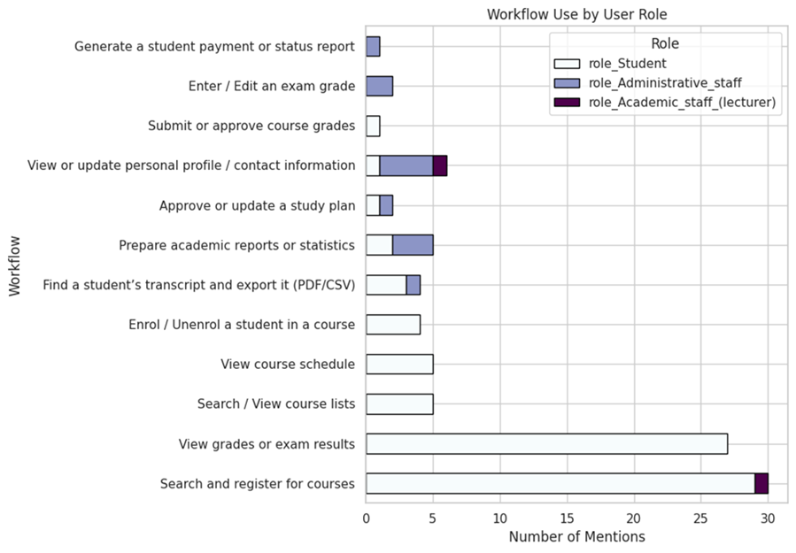

Difficulty, clarity, cognitive load

The difficulty ratings show that most workflows are not complex by nature. Intrinsic difficulty stays mostly between levels 1 and 3, which means users understand the tasks and do not find the underlying logic hard. In contrast, extraneous difficulty is consistently high across all workflows. Many respondents rated interface-related effort at levels 4 or 5, indicating that unclear labels, fragmented navigation, and unpredictable page structure create extra mental load. Clarity importance follows the same pattern, with most users rating it at level 3 or 4. These three signals that intrinsic difficulty, extraneous difficulty, and clarity importance form the cognitive-load profile of the system and are illustrated in Figure 2.X (boxplots).

The numeric values confirm the same patterns seen in workflow frequency. Student workflows have low intrinsic difficulty but high extraneous difficulty due to menu structure and inconsistent terminology. Administrative workflows show both higher intrinsic complexity and high clarity dependence. These results appear clearly in Figure 2.X (my numeric summary table). Together, the difficulty and clarity ratings show that the main source of effort in LUIS comes from how the system presents actions and information, not from the tasks themselves. This provides a direct link to the CLT discussed in the theoretical part and explains why later redesign steps focus on reducing extraneous load.

Taken together, these distributions confirm that the main source of cognitive effort in LUIS does not come from the nature of the tasks, but from how the system presents actions, labels, and navigation. To summarise these patterns in a compact format, the main findings on intrinsic difficulty, extraneous difficulty, and clarity importance are presented in Table 2.X in Apendix 2. This summary shows how user groups experience different types of load and which aspects of the interface contribute most to unnecessary effort.

**Priority scoring**

The priority scoring step combines four indicators for each workflow: intrinsic difficulty, extraneous difficulty, clarity importance, and the frequency of workflow each respondent uses. This creates a single numeric value that reflects how demanding a workflow feels in practice and how often users encounter problems.

The highest priority scores appear in administrative workflows: transcript export, academic report preparation, and exam grade entry. These tasks involve multi-page paths, unclear field structures, and strict sequences. They consistently show high extraneous difficulty and high clarity importance. This indicates that most of the effort comes not from the task logic but from the way information is presented.

Student workflows such as course registration, viewing grades, and viewing schedules fall in the medium range. These tasks are used far more often, but their structure is simpler. Their priority scores come mainly from unclear navigation, hidden actions, and inconsistent terminology. These workflows are high-volume, but not structurally heavy. The results show two separate problem types:

1. Administrative workflows contain deeper structural issues and generate the highest cognitive load.
2. Student workflows are overloaded with navigation friction and unclear labels.

For redesign planning, this means structural improvements are needed for administrative tasks, while student-facing tasks require better navigation, clearer hierarchy, and more predictable page structure. A horizontal bar chart of these scores is included as Figure 2.X, and full scoring outputs are provided in Appendix 2.

**Correlations**

A correlation matrix was generated for the main numeric variables in the dataset: intrinsic difficulty, extraneous difficulty, clarity importance, task time, steps, workflows used, and the composite priority score (Figure 2.X). The results show a consistent pattern across all workflows.

First, extraneous difficulty has a clear positive correlation with the priority score. This means that workflows which feel confusing, unclear, or hard to navigate are also the ones users want improved the most. This supports the earlier finding that most usability problems in LUIS come from interface structure rather than the task itself.

Second, clarity importance also correlates strongly with the priority score. Users rate workflows as a higher priority when clear labels, predictable steps, and consistent navigation matter for completing the task. In other words, when clarity is missing, the workload increases and users highlight the workflow as a problem area.

Intrinsic difficulty shows a smaller relationship with the priority score. Users rarely struggle with the logic of the task; they struggle with how the system presents it. This pattern confirms that cognitive load mainly comes from design choices, navigation paths, field visibility, terminology, not from the academic tasks themselves.

Finally, task time and steps_numeric show almost no meaningful correlation with the other variables. Users do not judge a workflow based on how long it takes or how many steps it includes. They react to whether the structure is understandable. This reinforces that improving clarity and reducing unnecessary interface friction are more important for usability than reducing task length.

Together, these correlations show that the highest-priority workflows are not the longest or most complex ones, but the ones where unclear design increases mental effort. This insight forms the basis for selecting workflows for redesign in the practical part.

**Device Use**

Device use was analyzed by splitting responses into desktop and mobile categories. This made it possible to compare how often users switch between devices and where they experience the most friction. Most respondents use a desktop or laptop, which fits the nature of many LUIS workflows, especially administrative tasks that involve several steps and require precise data entry.

Mobile use is also common, mainly among students. Many users access LUIS on both desktop and mobile, which means navigation and clarity issues appear across screen sizes. These problems are not limited to one environment.

Administrative staff rely almost entirely on desktop devices. Their workflows need a larger screen and more stable layout. Students move between devices more often and use LUIS during lectures, between classes, or while checking grades on the move. On small screens, unclear labels and crowded layouts become even harder to manage.

Figure 2.X shows the initial device distribution of 86 desktop and 55 mobile device users collected in the Google Forms survey. It demonstrates the general pattern: desktop use dominates, and mobile use is also significant.

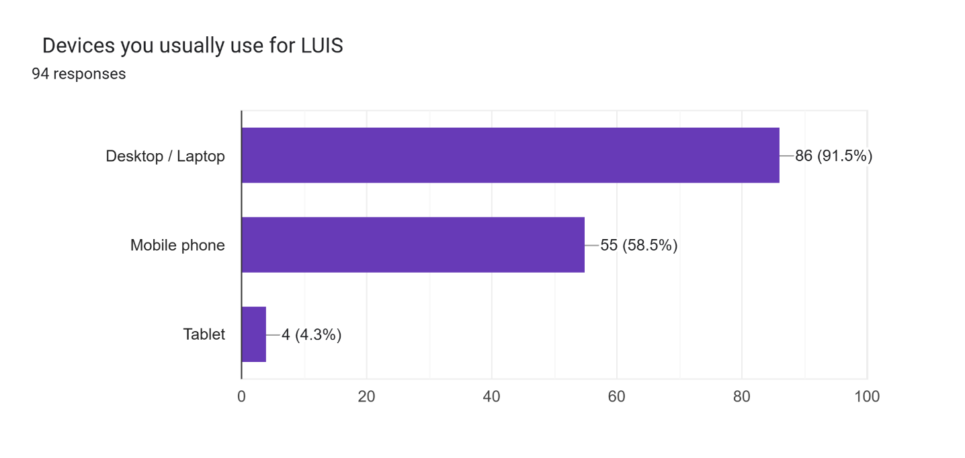

Figure 2

Python analysis helps reveal more detail. When device data was converted into separate indicators, clear patterns appeared: most users use desktop, many also use mobile, and only a small group uses mobile alone. This matters because the system must work well on both screen types. These patterns support the redesign decision to test the main administrative workflow on desktop and the most problematic student workflow on mobile.

|  |  |  |  |
| --- | --- | --- | --- |
| **User Group** | **Uses Desktop** | **Uses Mobile** | **Total Users** |
| All respondents | 84 | 55 | 92 |
| Desktop only | 37 | – | 37 |
| Mobile only | – | 8 | 8 |
| Uses both | 43 | 43 | 43 |
| Tablet users | 4 | – | 4 |

Device Distribution Table.

* + 1. Summary of Quantitative Findings

The automated analysis confirms the same patterns seen in the manual review but adds more detail. Intrinsic difficulty is low across most workflows, which means the tasks themselves are simple. The highest signals come from extraneous difficulty and clarity importance, showing that users struggle with the interface rather than with the task logic. Correlations also show that workflows with unclear labels, inconsistent paths, or several screens receive the highest priority for improvement.

Role-based patterns highlight clear differences. Students mainly struggle with navigation in course and grade workflows. Administrative staff face higher load in complex, multiscreen tasks such as exam grade entry, enrolment, and report preparation. This shows that redesign work cannot rely on one universal solution.

Device use adds another layer. Most respondents work on desktops, but many students also use LUIS on mobile. This means student-facing workflows should be examined on mobile as well, while administrative workflows are more relevant on desktop.

These results guide the choice of workflows for the redesign. Administrative tasks require structural simplification, while student tasks require clearer labels and more predictable navigation. The next step is NLP analysis, which looks at how users describe these problems in their own words and checks whether the qualitative themes match the quantitative signals.

## NLP Analysis Results

Tokenisation and basic cleaning

After creating the open_text_all column, the text was prepared using simple NLP cleaning steps. Each comment was lowercased, split into individual tokens, and stripped of punctuation, digits, and stopwords. This produces a set of tokens that contains only meaningful words relevant to how users describe their experience.

The cleaned tokens were stored as a new column and also combined into one list for later frequency analysis. This step reduces noise in the text and makes it easier to see recurring usability terms instead of grammatical fillers. Because the corpus is small, the cleaning process stays simple and focused on interpretability rather than complex modelling.

Lemmatization

Lemmatization was applied to make the language in the comments more consistent. Each token was reduced to its base form, so variants like labels/label or confusing/confusion appear as one term. This creates a new lemmas column, which becomes the main input for the later frequency counts, collocations, and theme grouping.

Because the corpus is small, lemmatization has a clear practical benefit: it reduces variability in wording and highlights repeated concepts more reliably. The original tokens were kept for reference, but all further steps use the lemmatized version to keep the analysis stable and readable.

Keyword frequencies and lexical patterns

After tokenisation and lemmatization, the next step was to look at simple word frequencies. All lemmas were combined into one list and counted. The most common words point directly to four areas: navigation, clarity, layout, and system behaviour.

Frequent lemmas include find, menu, label, field, unclear, confusing, hidden, small, slow, and error. A bar chart with the 20 most frequent lemmas is included in Figure 2.X. These match the quantitative results. Words like find, menu, label, and field show that users struggle to locate actions or understand labels. Terms such as unclear and confusing point to naming problems. Words like hidden, small, and far refer to visibility and placement issues. Slow, validation, and feedback describe timing and system response.

These terms form small lexical groups that reflect how users experience the interface:

1. orientation problems (menus, pages, views)
2. unclear terminology (labels, names)
3. visibility and layout issues (hidden, small)
4. slow or late feedback (validation, error)

Figure 2x

Collocations and bigram patterns

Frequency counts show which words matter, but not how users connect them. To see which terms appear together, bigram collocation analysis was run using NLTK’s BigramCollocationFinder with PMI scoring. The analysis used the lemma list and included only bigrams that appeared at least twice, so accidental pairs were filtered out.

The top bigrams show clear patterns. Phrases such as search function, main page, get stuck, and duplicate step point directly to navigation and workflow structure. Users describe searching inside menus, returning to the main page, and repeating the same steps. Bigrams like access permission, permission issue, and issue block reflect role-based problems. These usually appear in administrative workflows or student actions that unexpectedly fail.

| **Theme** | **Example Bigrams** | **What They Indicate** |
| --- | --- | --- |
| **Navigation & Structure** | *search function*, *main page*, *get stuck*, *duplicate step* | Users struggle to find actions, return to main screens, or avoid repeated steps. |
| **Permissions & Access** | *access permission*, *permission issue*, *issue block* | Role-based restrictions or unexpected blocks during tasks. |
| **System Feedback & Timing** | *validation error*, *system feedback*, *appear late*, *performance slow* | Late messages, slow responses, and unclear system states. |
| **Conceptual Clarity** | *make sense*, *sense click* | Confusion about why actions are required or how pages connect. |

The strongest bigram patterns fall into four groups: navigation, permissions, system feedback, and conceptual clarity. Table 2X .

Another group of bigrams relates to system feedback and timing. Pairs such as validation error, system feedback, appear late, and performance slow show frustration with late or unclear messages. Users often complete a form and only then receive an error, which increases extraneous load and forces them to redo steps.

Finally, phrases like make sense, get stuck, and sense click show conceptual confusion. These comments suggest that some parts of the system feel illogical or hard to interpret, which links directly to the clarity and terminology issues seen in the quantitative results.

Overall, these collocations show that users do not experience single problems. They describe small chains of difficulty: searching menus, meeting duplicated steps, receiving late validation, and dealing with unclear logic. These patterns support the earlier findings and highlight how interface structure contributes to cognitive effort.

**Word clouds and visual summaries**

To provide an intuitive visual summary of the corpus, the analysis includes a word cloud based on the lemmas. The word cloud was generated in Colab using the wordcloud library (Figure 2x). While word clouds are visually oriented and not analytical tools on their own, they are useful for communicating the dominant themes to non-technical readers.

The main word cloud shows the same core vocabulary that appeared in the frequency tables: find, menu, label, unclear, confusing, terminology, hidden, small, far, slow, validation, and error. These words form a visible cluster in the center of the image, with less frequent terms surrounding them.

(Figure 2.X: Word cloud of open-text responses)

In addition to the global word cloud, topic-specific word clouds were created for each LDA topic (see Section 2.8.7). These show the most important words for four inferred themes: navigation, terminology, errors and feedback, and layout. Each topic cloud uses a separate colour map and title overlay, making it easier to communicate differences between (Figure 2x)

(Figure 2.X: Word clouds- Theme Specific)

**Thematic grouping and topic modelling**

To move beyond single words, the comments were organized into broader themes using two simple methods: rule-based thematic grouping and an LDA topic model. First, a small theme dictionary was built from the most frequent lemmas and bigrams.

1. Words about menus, pages, fields, and searching were grouped as navigation.
2. Words such as unclear, confusing, terminology, name were grouped as **clarity and terminology**.
3. Words like hidden, small, far, away, duplicate formed a **layout and visibility** theme.
4. Words such as slow, late, feedback, validation formed a **performance and feedback** theme.
5. Permission, access, block formed a smaller permissions theme.

A helper function tagged each comment with one or more themes. Navigation was the most common, followed by clarity/terminology, layout/visibility, performance/feedback, and permissions. This order matches the quantitative results, where most friction came from finding actions and understanding labels.

Second, a small LDA model (4 topics) was run to check whether an unsupervised method produced similar patterns. It did.

1. navigation (find, menu, mobile, search, stuck)
2. terminology and clarity (unclear, terminology, field, hidden, small)
3. errors and system feedback (validation, error, late, slow, missing)
4. layout and visibility (label, page, confusing, field, menu)

Each comment was assigned to its most likely topic. Table 2X shows the main LDA topics with their keywords, how users describe each issue, and what it means for the interface. Students mostly fell into navigation and terminology topics. Administrative staff concentrated in topics about errors, slow feedback, and duplicated steps in multi-screen workflows. Lecturers appeared only in a few comments and were mainly linked to terminology and layout issues.

The two methods arrive at almost identical themes, which strengthens the reliability of the findings. Across all comments, users describe the same set of issues: getting stuck in navigation, unclear naming, hidden or poorly placed elements, delayed messages, and occasional permission blocks.

|  |  |  |  |
| --- | --- | --- | --- |
| **Topic** | **Main Keywords** | **What Users Describe** | **UI/UX Meaning** |
| **1. Navigation** | find, menu, right, mobile, use | Trouble locating actions, getting stuck, unclear paths | Improve structure, surface key actions, reduce steps |
| **2. Terminology** | unclear, terminology, hidden, small, field | Labels and field names feel confusing or misleading | Standardize naming, simplify language, improve clarity |
| **3. Errors & Feedback** | validation, appear, late, feedback, slow, missing | Delayed system responses and error messages | Faster feedback, clearer system states, visible validation |
| **4. Layout & Visibility** | names, confusing, field, label, menu, page | Layout feels inconsistent; elements are hard to notice | Clean layout, stronger hierarchy, consistent placement |

Table 2X Summary of LDA Topics in User Comments

## Summary of analytical findings

The analysis combined survey data, structured processing, and simple NLP to see where LUIS creates extra effort. Across all methods, the pattern was the same: the tasks are not difficult, but the interface design makes them feel harder.

The quantitative results showed low intrinsic difficulty and consistently high extraneous difficulty and clarity importance. Users know what they need to do, but they struggle to find the right pages, understand labels, or move through multi-step workflows. Students mainly report problems in navigation-heavy tasks such as course registration and viewing grades. Administrative staff report a different type of friction in complex workflows such as grade entry, report preparation, and study plan updates. Device use also matters: students switch between desktop and mobile, while administrative users mostly stay on desktop. This helped clarify which environments the redesign should address.

The NLP results match the numeric patterns. Frequent words and collocations point to navigation issues, unclear terminology, hidden or small interface elements, slow system feedback, and duplicated steps. Topic modelling grouped the comments into four themes-navigation, terminology, layout, and system feedback. These themes appear across user roles and link directly to higher extraneous load. NLP also revealed issues not visible in the structured fields, such as late validation messages and inconsistent naming.

Together, the quantitative and NLP results show a clear picture: LUIS needs simpler navigation, clearer terminology, better visibility and feedback, and layouts that work for both desktop and mobile. Based on these findings, two workflows were selected for the practical part: Enter/Edit an Exam Grade (desktop) and Search and Register for Courses (desktop and mobile). Transcript Export is kept as an optional third workflow.

## Workflow Selection for Practical Part

The results show that LUIS creates unnecessary effort because of unclear labels, long navigation paths, hidden elements, and slow feedback. These findings support the government’s decision to update and redevelop the system. For this study, the focus is narrower. Author selected the workflows that create the strongest usability pressure and appear consistently across the quantitative and NLP analysis.

1. Exam Grade Entry (desktop)

This workflow has the highest average priority score in the quantitative results. It combines higher intrinsic difficulty with very high extraneous difficulty and clarity importance. Administrative staff describe it as long, fragmented, and stressful because it involves several steps across multiple screens and carries high responsibility. The NLP results add detail: users mention late validation errors, unclear field names, and uncertainty about where changes are saved. For these reasons, exam grade entry is selected as the main desktop workflow for redesign.

1. Search and Register for Courses (desktop and mobile)

This is the most frequently mentioned workflow in the survey and generates the largest number of student comments. The task itself is simple, but users describe confusion caused by navigation, unclear terminology, hidden elements, and inconsistent page structure. It appears strongly in the NLP themes of navigation and unclear labels. Many students use mobile devices for this workflow, and the comments show that mobile navigation increases cognitive effort. Because of this, the workflow was selected for redesign in both desktop and mobile formats.

Together, these workflows cover the most urgent problem areas that are realistic to address within this thesis. Exam grade entry represents the most demanding administrative task on desktop. Course registration captures the most problematic student-facing workflow on mobile. Focusing on these two workflows allows the redesign to respond directly to the strongest evidence from both the quantitative and NLP results.

Chapter Summary

The analytical part combined quantitative survey data, structured data processing, and NLP analysis to understand where LUIS creates unnecessary effort for its users. Across all methods, the same pattern appears: the tasks themselves are not difficult, but the design of the system makes them feel demanding.

The quantitative results show that intrinsic difficulty is low, while extraneous difficulty and clarity importance are consistently high. Users understand what they need to do, but they struggle to find the right pages, interpret labels, or complete multi-step workflows without interruption. Role-based patterns highlight different sources of friction: students face navigation problems in workflows such as course registration and grade viewing, while administrative staff deal with complex, multi-step tasks such as grade entry, report preparation, and study plan updates. Device analysis adds one more layer. Students switch between desktop and mobile regularly, while administrative workflows remain almost fully desktop-based. This shows which environments matter most for redesign.

The NLP analysis confirms these findings. Frequent words and collocations point to the same problems: unclear terminology, confusing navigation, hidden or small interface elements, duplicated steps, and slow or late system feedback. Topic modelling groups the comments into four themes-navigation, terminology, layout, and system feedback-which match the quantitative patterns. Users describe getting stuck, moving between several pages, and guessing the meaning of labels, all of which point to high extraneous cognitive load. NLP also reveals problems that are not visible in the structured fields, such as late validation messages and inconsistent naming.

Together, the quantitative and NLP results show a consistent picture of what needs to be improved in LUIS: shorten navigation paths, use clearer terminology, improve visibility and feedback, and adapt workflows to both desktop and mobile. These insights guided the choice of workflows for the practical part: “Exam Grade Entry” on desktop and “Search and Register for Courses” on both desktop and mobile.

Future work could expand this analysis by using system logs. Although logs were not available for this study, the data-processing and NLP steps used here can be reused when logs become accessible, helping evaluate the new system and support longer-term development.

Overall, the analytical part gives a clear and consistent view of how LUIS creates unnecessary cognitive load and which workflows matter most for redesign. These findings form the base for the practical part, where the selected workflows were reconstructed to reduce friction and better support different user roles and device contexts.

# Practical Part II: UX Case Study

## Design Principles Derived from Analysis

Based on the results of the analytical part, the next step is to apply these findings to the redesign of selected LUIS workflows. The research showed that users struggle not because the tasks are complex, but because the interface adds unnecessary effort. In this practical part, the author focuses on reducing this extraneous load and rebuilding the workflows so they feel more predictable and easier to complete. The redesign simplifies structure, shortens navigation paths, and improves system feedback. Key actions are placed in stable, predictable locations with clear, action-based labels. Deep menu paths and duplicated pages are removed, so users no longer get lost or repeat steps. Visibility is improved with real-time validation and short confirmations placed close to the action area. Related tasks are grouped together on one screen to reduce switching, following the split-attention principle. The layout uses a consistent hierarchy (heading → subheading → main content → actions), and the action buttons stay in the same place across workflows. These changes are directly informed by survey and NLP findings and guide the reconstruction of both administrative and student-facing workflows in the following sections.

The redesign also adapts each workflow to the device context identified in the survey. Students often switch between desktop and mobile, so the layouts are built separately. Mobile uses a simple one-column structure with larger tap targets, fewer elements per screen, and collapsible sections for long information. Desktop keeps wider tables, stronger overview, a stable left navigation, and a persistent action bar so key buttons stay in the same predictable place. Basic WCAG 2.2 principles are applied throughout: high contrast for text and icons, no colour-only meaning, large touch areas on mobile, and clear keyboard focus paths on desktop (W3C, 2024). These choices follow the usage patterns seen in the data and aim to reduce confusion across different user groups.

## Selected Workflows & Existing Problems

The workflows chosen for redesign come directly from the quantitative and NLP results. Exam grade entry showed the highest pressure for administrative users, with high intrinsic and extraneous difficulty, unclear field structure, and several points where users reported getting stuck. Course search and registration appeared most often in student comments, especially in mobile scenarios, and showed repeated patterns of confusing navigation, unclear labels, and hidden actions.

These two workflows represent the strongest problem areas in the system. They capture different types of friction:

1. Administrative workflows with long, multi-step structures and high responsibility.
2. Student workflows with simple task logic but high navigation overhead, especially on mobile.

The practical part follows directly from these findings. The goal is to reduce unnecessary steps, improve clarity, and support the contexts users work in. For this reason, exam grade entry is redesigned for desktop, while course search and registration are redesigned for both desktop and mobile.

**Mobile Course Registration - Existing Problems**

The student mobile view shows major usability problems without considering course registration. In both screenshots, the interface displays only a header, a “Grades” or “E-talons” dropdown, and a large empty area. No courses, no registration options, and no navigation path to them are available. The layout collapses into a narrow, non-responsive structure that hides core actions. Important elements are pushed off-screen, and the menu structure does not adapt to mobile. As a result, students cannot access course lists, registration functions, or even basic academic information without switching to a desktop.

The visuals highlight several issues:

1. Key actions are missing completely (no visible link to courses or registration).
2. Interface loads as almost a blank screen, with only a title bar and a single dropdown.
3. The hierarchy is unclear, and the system does not signal where course-related actions are located.
4. Tabs (“Profile”, “Studies”) overlap and compete for attention, but neither reveals course functions.
5. Navigation relies on desktop-style menus, which do not render on mobile.

This confirms the survey results: students struggle most with navigation and visibility on mobile. The screenshots illustrate why- the system does not show essential workflows in the mobile view, which forces students to switch devices and creates unnecessary frustration.

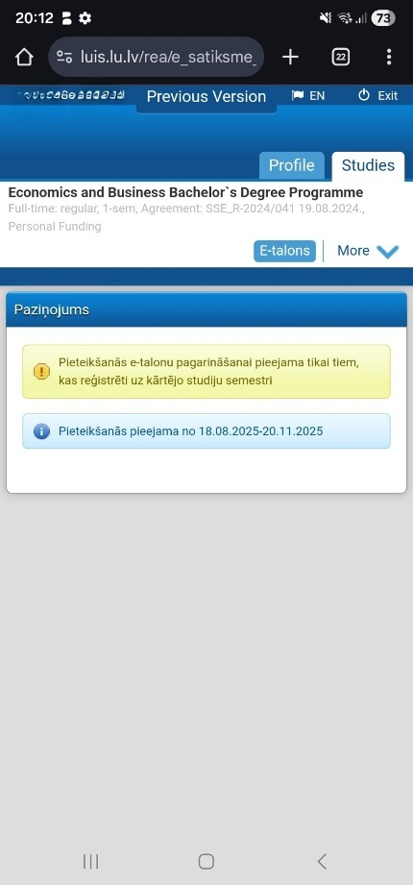 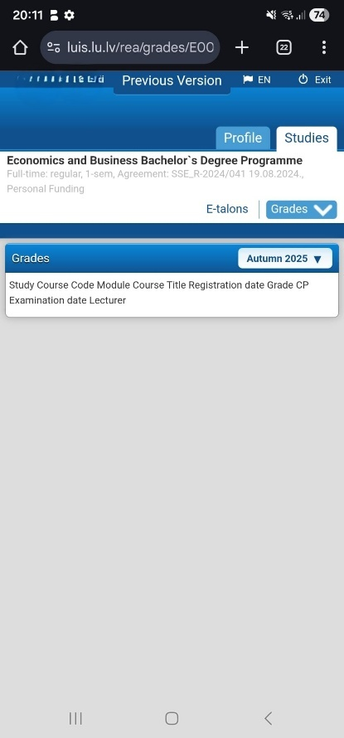

Figure 3.1. Existing LUIS Mobile Interface Visuals

**Desktop Course Registration - Existing Problems**

The desktop version of course registration shows the same structural issues as the mobile view in a wider layout. The workflow is split across several screens, and most elements are hidden inside collapsible folders. Students must search through multiple menus to understand where to start.

The page layout is overloaded. The top section repeats programme information, while the core actions sit far below the fold. This pushes essential elements out of view and forces unnecessary scrolling. The “Courses on offer” block is also presented as an empty table with no clear entry point, even when courses are available. The two columns (“Course list” and “Applied for courses”) create visual noise and do not support the task flow.

Navigation inside the registration tree is unclear. Categories such as A-Core, B-Specialisation, and C-Elective are hidden inside expandable folders. Their naming is not meaningful for first-year students and does not give any cues about which courses belong where. The system does not show basic affordances like a clear “Register” button next to each course.

Users reported in the survey that the structure feels unpredictable. The screenshots illustrate repeated issues:

1. the registration table shows many empty rows with dashes
2. action buttons are placed far away from course titles
3. the status messages (“Registration has expired”) appear with no colour coding
4. the left navigation switches between unrelated states

Overall, the desktop workflow requires students to click, expand, and re-check several sections before they find relevant courses. This matches the quantitative data on high extraneous difficulty and the NLP themes on navigation and unclear labels. The screenshots demonstrate these problems clearly.

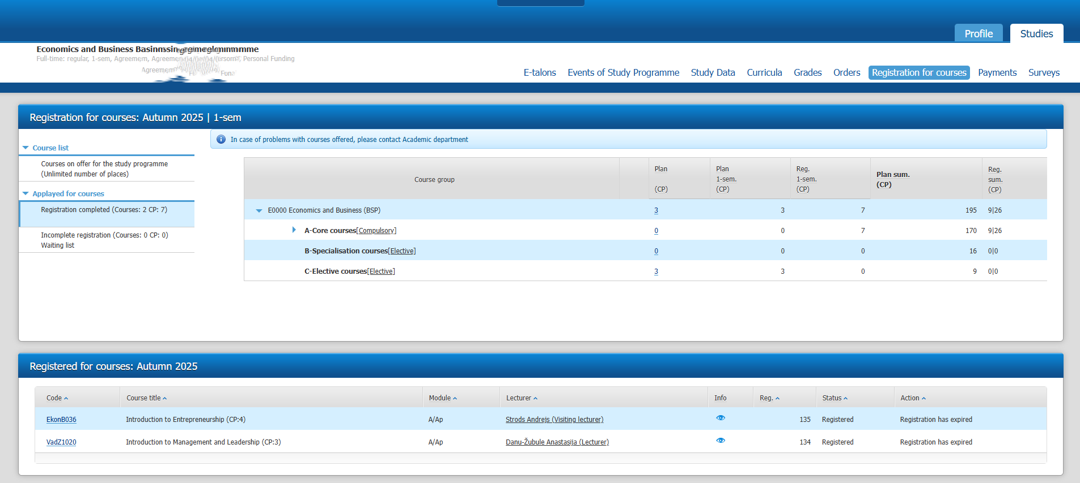

Figure 3.2. Desktop course registration screen – unclear structure

**Exam Grade Entry - Existing Problems**

The Grade entry existing workflow visuals show that the grade-entry interface is visually overloaded and difficult to interpret. The first issue is the amount of information placed on one screen without any grouping. Multiple long tables stacked together, each containing student names, course codes, statuses, registration dates, grade versions, and action buttons. Because everything uses the same beige background and the same font size, nothing stands out. Users must scan each row manually to find the right place to enter or edit grades, which increases unnecessary effort Figure 3.2. in Appendix 6.

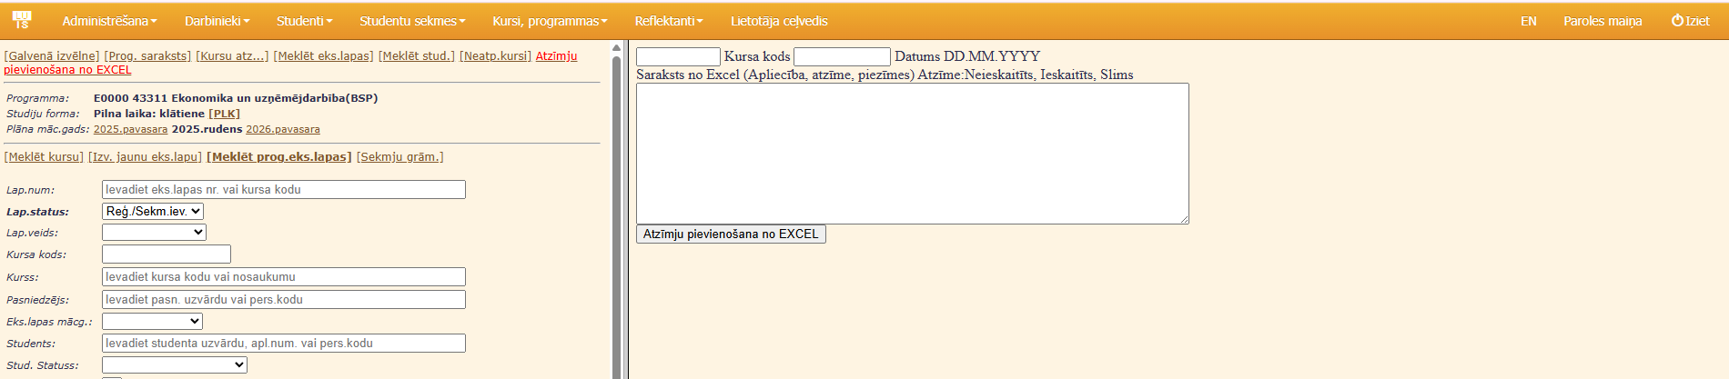

Figure 3.4. Fragmented Grade Entry Workflow.

Figure 3.3. and Figure 3.3. highlight how fragmented the workflow is. Before reaching the actual grade-entry table, users must complete a long set of filters: programme, course code, lecturer, student, status, academic year, and more. Many fields repeat information or require very specific internal codes that users do not always know. The filter section takes up a large part of the screen, pushing the functional area far below. This creates extra scrolling and makes it easy to miss steps.

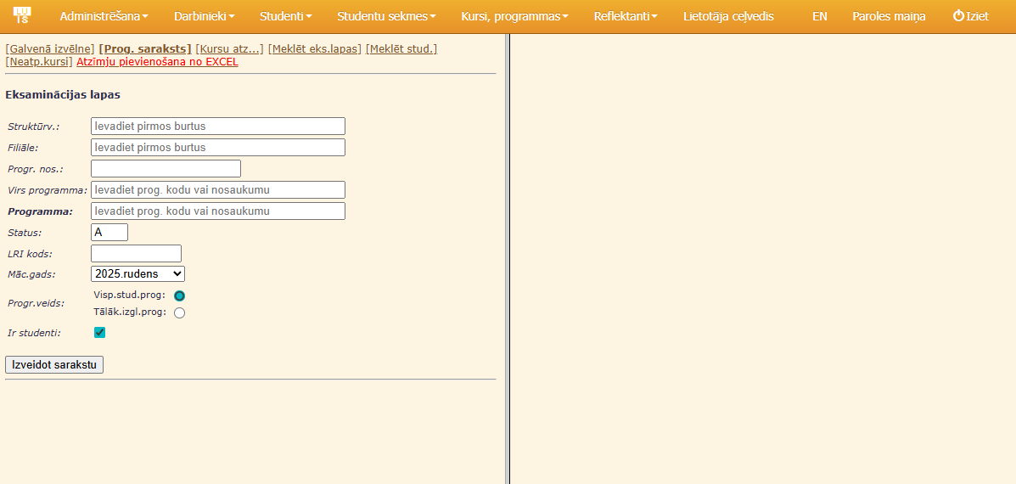

Figure 3.3. Fragmented Grade Entry Workflow.

Figure 3.2. in Appendix 6. shows the result of running these filters: a long, dense table with more than a dozen columns. Columns for registration status, study status, exam version, editing actions, and print options all appear next to each other. The table does not prioritise grade entry, even though it is the main purpose of the workflow. Instead, the most relevant information (grades) sits between several unrelated administrative fields. Because the table displays a full list of students without any grouping or visual hierarchy, users must carefully trace each row from left to right to avoid mistakes. This is demanding, especially in larger cohorts.

Across all three screenshots, the layout offers no supportive cues. There are no fixed headers, no sticky areas, and no clear separation between searching, editing, and confirming grades. The design spreads the workflow across multiple panels and forces the user to keep switching focus. Users described this as stressful and confusing, and the screenshots reflect the same problem: too much information on one screen, too little structure, and no guidance on what action comes next. This creates high extraneous cognitive load and increases the risk of errors during grade entry.

## Redesign Strategy

The redesign strategy follows directly from the analytical results and the cognitive load principles discussed earlier. The aim is to reduce unnecessary mental effort, create predictable structures, and support users on both desktop and mobile. The process combines information architecture, terminology updates, UX conventions, and accessibility basics. This section explains how the redesign work is organized and how each stage was completed.

**Workflow Steps**

| Workflow | Original steps | Redesigned steps | Reduction (%) |

| ------------------- | -------------- | ---------------- | ------------- |

| Enter/Update Grade | 14 | 7 | –50% |

| Find Study Plan | 9 | 5 | –44% |

| Course Registration | 11 | 6 | –45% |

**Target Users & Personas**

The redesign starts with clarifying what each workflow must achieve and who the redesigned interface is built for. To keep the work focused on real behaviour patterns from the survey, three short fictional personas are used. Personas are a standard UX method for describing typical users in a simple way. They help translate the analytical findings into clear design decisions and show the specific problems each group faces. The survey and NLP results showed clear differences between students and administrative staff, and between mobile and desktop use. Using personas helps keep these differences visible throughout the redesign process and supports the explanation of task flows, wireframes, and prototype choices.

Student Persona — Mobile (Laura)

Laura is a first-year student who checks LUIS several times a day Figure 3.5. She uses a mobile phone most of the time, including during lectures. She struggles with small buttons, unclear labels, and finding where to register for courses. She wants quick access to grades, course lists, and transcripts without clicking through several screens.

Figure 3.5

Student Persona — Desktop (Kristaps)

Kristaps is a second-year student who prefers to use a laptop Figure 3.5. He finds the desktop version visually crowded and often searches for course information in several different menus. He wants a simple course list with clear categories and predictable actions. He prefers to see full course details in one place.

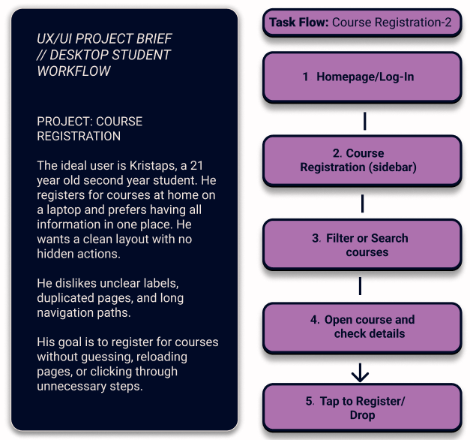

Figure 3.5

Administrator Persona — Grade Entry (Anna)

Anna is an administrator responsible for exam grade entry (Figure 3.5). She uses a desktop and works with LUIS daily. Her main problems are long multi-screen workflows, unclear field naming, hidden functions, and late validation errors. Grade entry requires precision and speed, so she needs a clean layout, stable table structure, and clear system feedback.

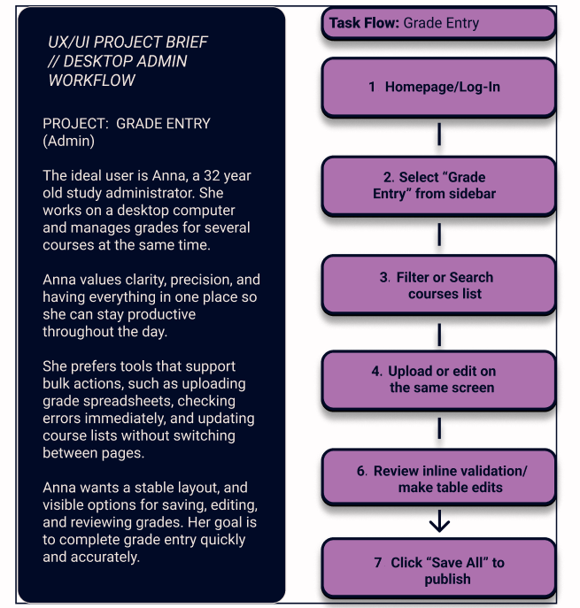

Figure 3.5

## Low-Fidelity Wireframes

The low-fidelity wireframes form the first step in shaping the redesigned workflows. They help organize the structure before adding visual style. The aim is to decide how information should be grouped, where actions should appear, and how to reduce unnecessary steps. These wireframes follow the redesign strategy defined earlier: shorter paths, clearer terms, fewer categories, predictable button areas, and earlier system feedback.

Wireframes were created in Figma using simple shapes and a neutral layout. They show structure and logic only- no typography, colour, or visual styling. This stage focuses on navigation flow, grouping, button placement, and the order of actions. It allows quick changes based on the analytical findings before moving to high-fidelity design.

These wireframes act as blueprints for the high-fidelity concept and support the user testing stage that follows.

* + 1. Low-Fi: Mobile Course Registration

The mobile wireframes created on Figma software use a simple one-column layout because students rely heavily on their phones and often struggle with crowded screens Figure 3.6. The structure focuses on keeping one clear entry point for course registration, reducing the number of taps needed, and making every action easy to reach with the thumb. The course list is presented as a clean vertical stream with short titles and essential details such as ECTS and course type. Each item functions as a large tap target instead of a small text link, which directly addresses the size and precision problems students described in the survey.

When a course is opened, the details appear in a single card with a clearly visible Register or Drop button. The action is placed in a stable position and does not require searching through several panels. After registering, the confirmation appears directly inside the same card to remove any uncertainty about whether the action was saved.

This layout tackles the main issues found in the analysis: long navigation paths, deep menu structures, small interactive elements, and unclear feedback. The wireframe reduces the path to course registration to one predictable route, keeps the interface light, and places actions where students expect them. It reflects the real usage pattern identified in the survey, where clarity and immediacy matter more than the number of features shown on screen.

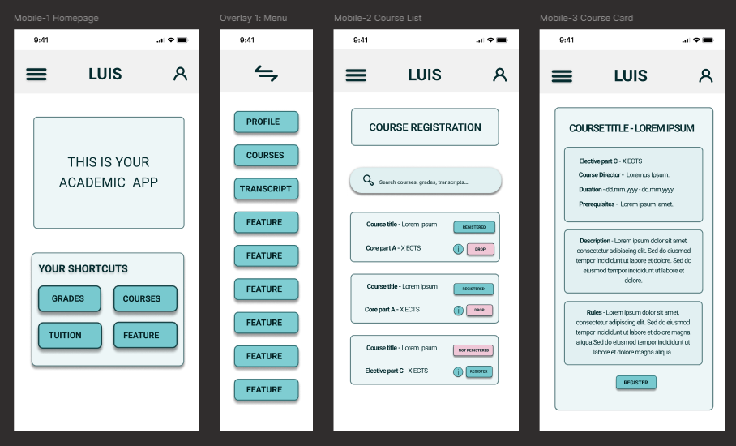

Figure 3.6. Mobile Lo-Fi Wireframes

* + 1. Low-Fi: Desktop Course Registration

The desktop wireframes keep more information visible at once, but the structure is much clearer than in the current system (Figures 3.10; and 3.6. 3.9. In Appendix 3). The left navigation stays stable across all screens, so students always know where they are. The course list is organized into a simple, readable table that shows only the necessary fields. Search, filter, and sort tools sit at the top where students expect them, reducing scanning time and unnecessary clicks.

The main interaction happens inside the course row itself. Registration and drop actions are placed close to the course name, making them easy to find without opening extra pages. When an action is taken, the feedback appears inside the same row to avoid losing context while scrolling.

These layout choices address the main problems students described in the survey: crowded tables, unclear actions, too many paths to the same task, and confusion after clicking buttons.

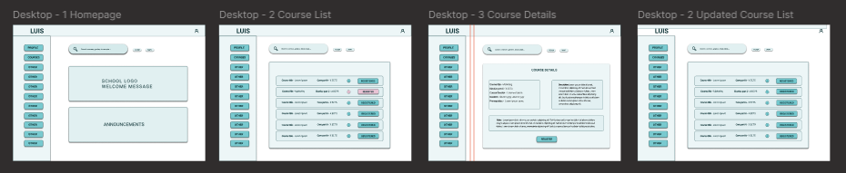

Figure 3.10. Student Desktop Wireframes

* + 1. Low-Fi: Grade Entry (Admin)

The grade-entry workflow focuses on reducing the long, fragmented steps that administrators deal with. The layout keeps everything on one page and uses a clear structure so the user doesn’t lose context. The redesigned wireframe keeps the course information, the grade table, and the main actions visible in a stable layout, which supports fast scanning and reduces the chance of errors (Figures 3.14. and Figures 3.11.-3.13.)

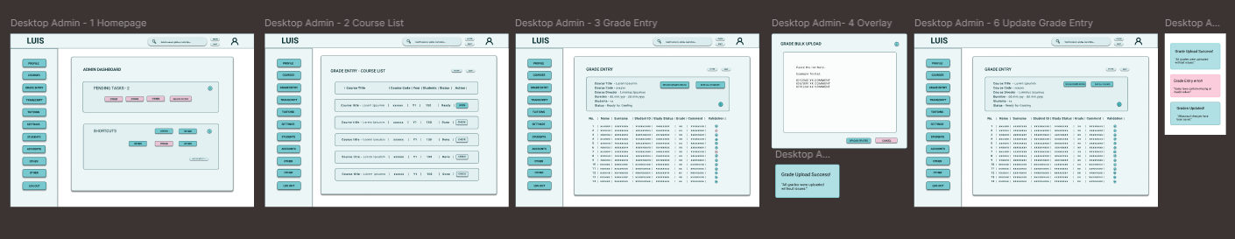

Figure 3.14. Admin Desktop Wireframes

The table is simplified into readable rows with larger input fields. Validation appears directly inside the row, not at the end of the process, so mistakes are caught early. A short summary block above the table shows course title, code, dates, and student count, giving the user immediate orientation before entering grades.

These decisions address the most common problems from the survey: complicated multi-step paths, late error messages, unclear button hierarchy, and dense tables that were hard to work with. The new structure creates a calmer workflow where the user stays on one page and receives feedback immediately.

## Prototype Development and Testing

This chapter presents the practical part of the research. It focuses on prototype design and testing aimed at improving the usability of LUIS. The redesigned interface was demonstrated through Figma prototypes, applying the UX, IA and CLT principles discussed in the theoretical part. Using prototypes of website before creating actual web pages is helpful and time saving, because it allows user testing before investing in expensive and complex development and having to create changes from the backend of the process.

For the practical part of this research, prototype interfaces for all three selected workflows were created in Figma to show possible usability improvements for LUIS (Figures 3.17. and Figures 3.18.- 3.19.in appendix 3) Figma allows quick testing of layout, colour, and navigation choices before real implementation. The (Figma, 2025) Smart Anime feature helps create smooth transitions between screens, showing how menus open, pages move, or buttons react. These animations make the interface easier to follow and reduce user confusion. Smart Animate connects matching layers between frames and automatically animates change such as size, colour, or position. This creates a more natural user experience during navigation and helps visualize how the final system might feel to use. Using such prototypes will make it possible to collect feedback on both visual clarity and emotional comfort, linking the design work directly to the psychological and usability principles discussed in the theoretical part.

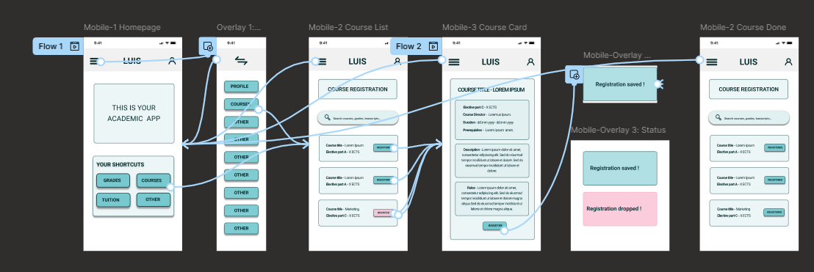

Figure 3.17.- Student Mobile workflow prototype wiring.

**Prototype Usability-Testing**

For the usability testing phase, the same participants who completed the original LUIS survey were invited to test the redesigned workflows. This kept the feedback consistent and allowed the new observations to be compared directly with the earlier comments and reported frustrations. The testing was carried out using interactive Figma prototype links (REFERENCE) embedded in a short Google Forms questionnaire (Apendix 1.3). This format was chosen because it allowed participants to open the prototype in their browser, complete the tasks, and immediately answer a few follow-up questions about clarity, effort, and overall experience.

The goal of the test was not to evaluate a finished interface, but to check whether the redesigned information structure and clearer workflow descriptions help users understand and complete tasks more easily. Participants received short tasks to complete. They rated ease of workflow, mental effort, and clarity.

## Prototype Testing Results

A total of 51 people participated in the second survey conducted during prototype testing: 35 student mobile users, 3 administrative staff users, and 13 student desktop users (Figure 3.xx.), more than half of the original 92 respondents. For the second survey, author tested the new LUIS workflows with the same three user groups: students on mobile, students on desktop, and administrative staff. All three sheets from the Excel file were loaded into Colab and cleaned into one dataset Workflow_Prototype_Test.xlsx. Renaming the columns to simple labels (difficulty, mental effort, easier than LUIS, comments) and added a user_group column as well as difficulty_rescaled, combined_score, tokens and lemmas columns for NLP processing.

Figure 3.xx. Number of prototype test responses.

One question used the opposite scale (1 = easy, 5 = hard), it was rescaled it to match the others. After this, all scores followed the same direction: 1 = negative, 5 = positive. This made the results comparable to the first survey.

The descriptive results showed improvement. On average, users rated the prototype as easy to use (4.06), required less mental effort (4.26), and felt it was easier than the current LUIS design (4.16). These findings were compared the overall results to the first survey. All three areas improved: ease increased by 0.50, mental effort by 1.74, and clarity by 0.66. This confirms that the redesigned workflows reduce confusion and lower cognitive load. (Table 3.8.)

| **Metric** | **Old Average** | **Prototype Average** | **Change** |
| --- | --- | --- | --- |
| Intrinsic Difficulty | 3.57 | 4.06 | +0.49 |
| Extraneous Difficulty | 2.52 | 4.26 | +1.74 |
| Clarity Importance | 3.50 | 4.16 | +0.66 |

Table 3.8. Change in Perceived Difficulty and Clarity After Prototype Testing

The user groups also gave different scores. Mobile students gave the highest ratings, which shows that the one-column layout works well on phones. Desktop students also rated the workflow positively, but a lower because they see more information on the screen. (Table 3.7) Admin users were more cautious, which makes sense because they usually work with complex tasks, and the prototype only showed simplified versions (Figure 3.xx.).

| **User Group** | **Ease** | **Mental Effort** | **Easier than LUIS** |
| --- | --- | --- | --- |
| Student (mobile) | 4.15 | 4.47 | 4.41 |
| Student (desktop) | 3.85 | 4.00 | 3.85 |
| Admin (desktop) | 4.00 | 3.00 | 2.67 |

(Table 3.7) Improvement of Mental Effort after prototype testing.

(Figure 3.xx).

Overall, the prototype test shows that the redesigned versions move the system in the direction of better clarity. The workflows feel easier, require less thinking, and are seen as an improvement over the current LUIS design. Ratings were consistently higher across all groups, especially for mobile users, who evaluated the prototype as the most intuitive version (Figure 3.x).

(Figure 3.x) Improvement of Mental Effort after prototype testing.

Author also checked the comments using the same NLP steps as in the main analysis. Most frequent words in prototype feedback shows the 20 most common words used in open-ended feedback after prototype testing Figure 3.xxx. The word *"course"* appeared most often, followed by *"everything"*, *"button"*, and *"clear"*. Positive terms like *"simple"*, *"good"*, and *"worked"* suggest overall satisfaction. Some mentions of *"confusing"* and *"nothing"* indicate isolated issues or neutral responses. The most common words were “clear”, “easy”, “fine”, “worked”, and “understandable”. The bigrams showed similar patterns. Users mostly spoke about clarity and smooth interaction, which supports the numeric results.

Figure 3.xxx

Word cloud visualization illustrates the same feedback patterns discussed in the previous chapter. Frequently mentioned terms like “course,” “everything,” “button,” and “clear” stand out visually, confirming the main usability concerns and positive impressions raised by participants. It provides a quick visual summary of the most common words used in open-text responses, helping to highlight recurring themes visualy.

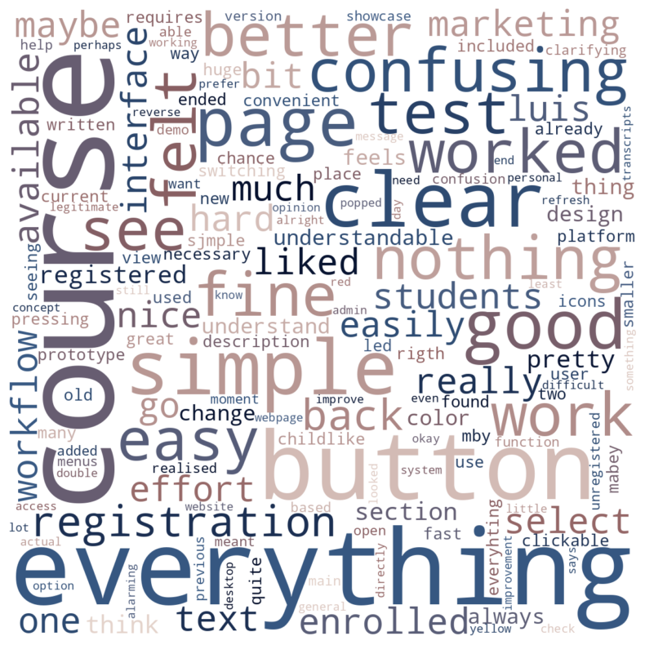

Figure 3.xxx. Word Cloud of Prototype Feedback

Summary of Testing Results

The workflow test shows that the redesigned information structure improves clarity and reduces cognitive load for both students and staff, which supports the idea that information architecture and layout hierarchy drive most of the usability improvements.

The test results confirm that the redesign direction is meaningful and that the main issues identified earlier, navigation complexity, unclear labels, and scattered information, were addressed effectively.

## UI Design Style Guide

The style library defines the visual rules that support the redesigned information architecture. It introduces a compact set of colours, typography, and basic components that keep the interface clear, predictable, and readable. The aim is not to finalise a visual identity, but to show how an updated academic system could look when guided by cognitive-load principles and accessibility requirements.

The colour scheme is limited to six functional colours (Table 3.x; Apendix 3; Figure 3.17). Each colour has a clear role, which reduces visual noise and prevents users from relying on colour alone to understand meaning. The palette is calm, low-contrast in tone, and aligned with WCAG 2.2 guidelines. This palette was chosen because it stays stable across mobile and desktop, reduces cognitive effort, avoids bright or highly saturated tones, and maintains sufficient contrast between text and background.

Figure 3.17- Style guide

The component set includes buttons, cards, search bars, and top navigation. All components follow the same rounding, spacing, and colour logic. The interface uses Roboto, a standard sans-serif typeface that remains readable in small sizes and works well on both mobile and desktop screens Figure 3.17. Using one typeface keeps the interface calm and consistent. It supports the principle of recognition over recall because the hierarchy is easy to scan:

* H1 (48 pt) – page titles
* H2 (32 pt) – section headers
* H3 (24 pt) – card headings
* H4 (18 pt) – action text
* P1 (16 pt) – regular body text

The layout follows an 8-point spacing system, which creates predictable rhythm across screens. It improves chunking and helps users understand grouping at a glance. Key rules:

* 8 px increments between smaller elements
* 24-32 px padding inside cards and containers
* Wide spacing between tap targets on mobile
* Actions placed close to the user’s main focus area
* This supports working-memory limits and reduces visual clutter.

The style library in this thesis is not a complete design system. Its purpose is to demonstrate how improved information architecture can be visually supported through stable hierarchy, accessible colour use, and consistent spacing. It provides a clear visual direction that future UX/UI teams can build on, without assuming a full redesign or final brand identity.

* + 1. High-Fidelity Design Proposal

The high-fidelity screens in this chapter show how the Style Guide can be applied to the redesigned information architecture (Figure 3. 15.). These screens are not interactive prototypes and were not used for usability testing. Their role is to demonstrate a possible visual direction that supports the structural and cognitive principles developed earlier.

Figure 3. 15 High-fidelity Mobile Screens

Because this research focuses on information architecture and cognitive load, full prototyping or animation was not required. The high-fidelity screens serve as a visual interpretation of the improved layout logic and help illustrate visual hierarchy, colour use, spacing and grouping, application of typography and icon style and overall tone of an updated academic interface. These screens show how a clean and predictable visual layer can reinforce the redesigned workflows described in the previous sections.

Mobile Homepage

The mobile homepage uses the new colour palette and spacing rules to create a clear entry point into the system. The top bar contains only three elements - menu, system name, and profile-which keeps orientation stable across all screens. The search field is placed prominently to reduce navigation steps, and four shortcut buttons give quick access to core tasks such as grades and courses. The single-column layout, large tap targets, and clean grouping support faster scanning and match the behaviour patterns identified in the survey.

Slide Out Menu

The slide-out menu follows the simplified navigation logic developed in information architecture redesign. It uses large buttons, short labels, and wide spacing to make every option easy to select on a small screen. The menu removes unnecessary nested categories and keeps all main items visible at once. This solves previous issues with deep navigation, inconsistent naming, and hidden options, while maintaining the same structure across all screens for predictability.

Course List (Mobile)

The mobile course list presents each course as a card with clear grouping of title, part, and ECTS. This one-column layout reduces scanning effort and avoids the crowded tables found in the original LUIS interface. The action state *Register* or *Registered* is placed directly on each card with a clear colour and label. This removes the need to open multiple pages to complete an action and provides immediate clarity about the status of each course.

Course Card (Details)

The course card organizes detailed information into readable blocks such as description, prerequisites, rules, and duration. The clean spacing and soft background colour support comfortable reading, and the *Register* button is placed in a consistent location at the bottom of the card. This layout solves earlier problems with scattered information and unclear hierarchy by presenting all relevant details on a single screen, without requiring additional navigation.

These high-fidelity style screens are not a finished interface but a visual demonstration of how the redesigned information architecture and psychological principles can be supported through a consistent visual layer. They help translate the structural improvements into a clear and modern direction that can guide future development work on LUIS.

## Future Work

Future work may build on the findings of this study by expanding the redesigned workflows into full workflow redesign. This would make it possible to observe real user behaviour, measure task completion times, and evaluate navigation paths in more detail. A next step would be to test the redesigned information architecture with a larger and more diverse sample of users, especially administrative staff, who work with more complex workflows and require higher precision.

Another direction for future work is the development of a complete design system for LUIS or its successor platforms. The style guide presented in this thesis can serve as a starting point for a full system with extended components, interaction patterns, and accessibility guidelines. Collaboration with developers from the national academic information systems could help align visual and structural decisions with technical constraints and long-term maintenance needs.

It would also be useful to analyze real system logs when they become available. Log data could confirm which workflows cause the most friction in everyday use and provide objective indicators of where redesign efforts have the strongest impact. This would allow deeper comparison between survey-based perceptions and actual user behaviour.

Overall, the findings of this thesis show that improvements in information architecture and usability alone can significantly reduce cognitive load. Future work could build this foundation by combining structural clarity with full UI implementation, stronger accessibility support, and long-term usability monitoring across different institutions.

Chapter Summary

The practical part demonstrates how the analytical findings can be translated into clearer workflows and a more structured interface concept for LUIS. The redesign focused on reducing extraneous cognitive load by simplifying navigation, improving terminology, grouping related information, and presenting clearer visual hierarchy.

User testing results show consistent improvement across all measured dimensions. Ease of workflow increased, indicating that users understood the simplified task paths. Mental effort dropped, which confirms that the new information architecture lowers unnecessary cognitive load. Clarity ratings also improved, showing that shorter labels and predictable layout make the system easier to follow. Role-based results reflect differences between user groups, but all groups show positive movement compared to the current LUIS version.

The evaluation supports the main hypothesis that structural and psychological design principles can meaningfully improve usability in academic information systems. The redesigned workflows demonstrate that many problems in LUIS are caused by presentation and structure, not by the underlying academic logic. A clearer information layout, consistent terminology, and well-grouped actions produce immediate benefits even in a non-interactive form. This confirms that changes at the information architecture level can reduce user confusion and improve task flow before any full UI rebuild.

Discussion

The findings of this thesis confirm that structural problems in academic platforms can be addressed effectively using cognitive-load principles and user-centered information architecture. The improvements seen in workflow clarity, reduced mental effort, and better navigation paths point to a larger implication: that even partial redesigns focused on clarity and structure can deliver measurable usability gains without full system rebuilding.

In the context of CLT, the distinction between intrinsic and extraneous load proved useful for identifying what kind of system improvements matter. LUIS workflows generally have low intrinsic difficulty - users understand what to do. But the system adds significant extraneous load through unclear labels, unpredictable navigation, and visual clutter. This means that academic logic is not the problem; how the system presents it is. The implication for future platforms is clear: design teams should prioritize reducing extraneous load first, even before addressing deeper functionality.

The results also reinforce the importance of separating IA from visual design. This thesis focused on reorganizing structure, grouping, and terminology, while keeping UI elements basic. Yet the benefits were already visible. This shows that strong IA can stand on its own and guide design decisions at every stage. For upcoming national systems that aim to merge existing platforms, this suggests a design-first, build-later approach - starting with navigation logic, role flows, and cognitive effort planning before UI development begins.

From a policy and governance angle, the findings support the idea that user experience is not a minor detail in digital public services - it directly impacts daily academic operations. Improving IA alone helped reduce confusion and effort among students and staff. This has implications for national digitalization goals: user testing, cognitive design, and clear structure should be standard practice in all academic system development.

The practical impact of this thesis is also relevant for institutional IT teams. With limited resources, small interventions such as label rewriting, layout restructuring, and navigation changes can still have large effects. These are realistic goals even in older systems like LUIS, where full platform replacement may take years. In that sense, the study offers a practical blueprint for low-cost, high-impact usability improvements.

Finally, the interdisciplinary method - combining survey data, NLP, interface design, and DH context - shows how universities can bridge theory and practice in digital development. This approach could be used in similar research or adapted for internal system audits, workflow testing, or prototype validation.

In short, the findings are not only about what is wrong with LUIS - they also offer a roadmap for how national academic systems in Latvia can evolve with clearer structure, lower cognitive load, and stronger user alignment.

CONCLUSION

This thesis explored how cognitive-load principles, information architecture, and simplified visual structure can improve the usability of academic information systems, using the LUIS as a case study. The main aim was to identify which design factors create unnecessary cognitive effort for users and develop a redesign strategy that reduces this load. The research combined theoretical insights, a structured analytical process, and a practical demonstration of redesigned workflows. The results show that usability problems in LUIS come mainly from the structure and organisation of the interface rather than the academic logic of the tasks themselves.

The theoretical part demonstrated that cognitive load theory, user-centered design, and visual hierarchy offer a clear framework for analysing academic systems. The distinction between intrinsic and extraneous load was especially useful. Most tasks in LUIS have low intrinsic difficulty, meaning users understand the academic rules behind tasks such as course registration or grade entry. However, the interface introduces high extraneous load through unclear terminology, inconsistent navigation paths, small interactive elements, and delayed feedback. These theoretical principles showed that reducing extraneous load should be the main priority when improving administrative information systems.

The empirical results confirmed these insights. Survey findings revealed low intrinsic difficulty but consistently high extraneous difficulty and clarity importance across all user groups. Students reported repeated issues with navigation and unclear labels, especially on mobile devices. Administrative staff worked with more complex workflows but still faced problems caused mainly by interface structure. NLP analysis supported this by showing repeated terms such as “find,” “menu,” “unclear,” “hidden,” “duplicate,” “slow,” and “error.” These patterns matched the quantitative data and showed that users struggle with how LUIS presents information rather than with the tasks themselves.

The practical part applied these findings by redesigning three priority workflows: mobile course registration, desktop course registration, and desktop grade entry. The redesign focused on shortening navigation paths, clarifying terminology, grouping related elements, applying predictable structure, and including a basic level of accessibility. High-fidelity style screens were created to show how improved information architecture could look visually. Although these screens were not tested as full interactive prototypes, they helped demonstrate how structural improvements translate into a clearer visual direction.

Usability testing with low fidelity interactive prototype screens showed clear improvements across all measured dimensions. Ease of workflow increased, mental effort decreased, and clarity ratings improved. Mobile users gave the strongest ratings, reflecting the benefits of a one-column layout and simplified grouping. Desktop students also showed positive responses, and administrative staff reported improvements in their complex workflows. These results confirm that improving information architecture alone can meaningfully reduce cognitive load, even without full UI implementation.

The study achieved its aim and confirmed its hypothesis. Targeted improvements in structure, terminology, and visual organisation can significantly improve the usability of an academic information system. The research demonstrated theoretical relevance by applying cognitive load principles to an academic information system and empirical relevance by showing measurable user improvements through redesigned workflows. The methods used in this thesis: survey analysis, NLP techniques, and structured redesign, form a replicable approach for other institutional platforms facing similar challenges.

The research question asked: How user-centered information architecture, informed by cognitive-load principles, can improve the usability of academic information systems and what the case of LUIS shows about reducing unnecessary mental effort? The results of this thesis show that clearer structure, consistent terminology, and improved visual grouping directly reduce extraneous cognitive load for all user groups. The case of LUIS demonstrates that many usability barriers come from how information is organized rather than from the academic tasks themselves. When navigation paths become predictable and interface elements follow a stable logic, users complete workflows with less confusion and effort. These findings show that cognitive-load principles are effective for improving academic information systems and can be applied in future national platforms.

Future research could continue this work by developing interactive high fidelity prototypes, running behavioral usability tests, and analysing real system logs when they become available. This would allow deeper evaluation of navigation patterns, error behavior, and system responsiveness. Another direction is the creation of a full design system for future national academic platforms based on the style guide developed in this thesis. There is also potential to publish parts of this research, especially the cognitive-load analysis and workflow redesign, in digital humanities or educational technology journals.

Overall, the research shows that improving information architecture is a strong and realistic way to modernize academic information systems. Clearer structure, consistent labels, and predictable visual layout help users complete tasks with less mental effort. The results provide a practical foundation for future design and development work on LUIS and similar systems as Latvia moves toward unified academic platforms.

LIST OF REFERENCES

Abdulai, R. T., & Owusu-Ansah, A. (2014). Essential Ingredients of a Good Research Proposal for Undergraduate and Postgraduate Students in the Social Sciences. *Sage Open*, *4*(3), 2158244014548178. https://doi.org/10.1177/2158244014548178

Alasmari, T. (2020). The Effect of Screen Size on Students’ Cognitive Load in Mobile Learning. *Journal of Education, Teaching and Learning*, *5*(2), 280–295.

Berry, D. M., & Fagerjord, A. (2017). *Digital humanities: Knowledge and critique in a digital age*. Polity.

Bird, S., Klein, E., & Loper, E. (2009). *Natural language processing with Python*. O’Reilly.

Cierniak, G., Scheiter, K., & Gerjets, P. (2009). Explaining the split-attention effect: Is the reduction of extraneous cognitive load accompanied by an increase in germane cognitive load? *Computers in Human Behavior*, *25*(2), 315–324. https://doi.org/10.1016/j.chb.2008.12.020

Darejeh, A., Marcusa, N., Mohammadi, G., & Sweller, J. (2024). *A critical analysis of cognitive load measurement methods for evaluating the usability of different types of interfaces: Guidelines and framework for Human-Computer Interaction* (No. arXiv:2402.11820). arXiv. https://doi.org/10.48550/arXiv.2402.11820

Duarte Nancy. (2019). *Data Story: Explain Data and Inspire Action Through Story*. IdeaPress Publishing.

Education and student information systems: OECD Digital Education Outlook 2023. (2023). In *OECD*. https://www.oecd.org/en/publications/oecd-digital-education-outlook-2023_c74f03de-en/full-report/education-and-student-information-systems_ef9f7b25.html

Ertel, Wolfgang. (2011). *Introduction to Artificial Intelligence*. Springer.

Faudzi, M. A., Cob, Z. C., Ghazali, M., Omar, R., & Sharudin, S. A. (2024). User interface design in mobile learning applications: Developing and evaluating a questionnaire for measuring learners’ extraneous cognitive load. *Heliyon*, *10*(18), e37494. https://doi.org/10.1016/j.heliyon.2024.e37494

Figma. (2025). *Smart animate layers between frames – Figma Learn—Help Center*. https://help.figma.com/hc/en-us/articles/360039818874-Smart-animate-layers-between-frames?utm_source=chatgpt.com

Ghafur, I. A., Abdurrahman, L., & Putra, S. A. (2025). Utilization of Process Mining to Analyze and Identify Improvement Opportunities in the New Student Admission Process. *Proceedings of the 2025 14th International Conference on Software and Computer Applications*, 6–12. https://doi.org/10.1145/3731806.3731832

Izglītības un zinātnes ministrija. (2020). *Augstākās izglītības iestāžu digitalizācijas izvērtējums Latvijā* (p. 80). Izglītības un zinātnes ministrija. https://ppdb.mk.gov.lv/wp-content/uploads/2020/12/Digitalizacijas_izvertejums_PETIJUMS.pdf

Izglītības un zinātnes ministrija. (2024, April 3). *ES fondu atbalsts augstākajai izglītībai un zinātnei (2021-2027)*. https://www.izm.gov.lv/lv/es-fondu-atbalsts-augstakajai-izglitibai-un-zinatnei-2021-2027

Izglītības un zinātnes ministrija. (2025, May 27). *4.2.2.11. Pasākuma “Studiju procesa digitalizācija” īstenošanas noteikumi* [Government presentation]. https://www.izm.gov.lv/lv/media/28545/download?attachment

IZM. (2025, May 27). *Latvijā uzsāk augstākās izglītības digitalizāciju: Modernizēts studiju process, mazāks birokrātiskais slogs un plašāka pieejamība studentiem | Izglītības un zinātnes ministrija*. Izglītības un zinātnes ministrija. https://www.izm.gov.lv/lv/jaunums/latvija-uzsak-augstakas-izglitibas-digitalizaciju-modernizets-studiju-process-mazaks-birokratiskais-slogs-un-plasaka-pieejamiba-studentiem

Jurafsky, D., & Martin, J. H. (2009). *Speech and language processing: An introduction to natural language processing, computational linguistics, and speech recognition* (Second edition). Pearson Prentice Hall.

Lamarre, E., Smaje, K., & Zemmel, R. (2023). *Rewired: The McKinsey Guide to Outcompeting in the Age of Digital and AI*. John Wiley & Sons.

Leppink, J., Paas, F., Van der Vleuten, C. P. M., Van Gog, T., & Van Merriënboer, J. J. G. (2013). Development of an instrument for measuring different types of cognitive load. *Behavior Research Methods*, *45*(4), 1058–1072. https://doi.org/10.3758/s13428-013-0334-1

Malviya, A., & Malmgren, M. (2019). *Big data for managers: Creating value*. Routledge.

Marek Pałys. (2024, December 2). *Understanding the Impact of Cognitive Psychology on UX Design*. Startup House. https://startup-house.com/blog/cognitive-psychology-ux-design

Melanie Mitchell. (2019). *Artificial Intelligence. A Guide For Thinking Humans.* Picador.

Ministru kabinets. (2024, June 25). *Rīkojums Nr. 522: Par investīcijas 2.1.2.1.i. “Centralizētās platformas un sistēmas” nolūka “Pašvaldību pakalpojumu digitālā transformācija un pašvaldību atbalsta procesu modernizācija un centralizācija, t. Sk. Sadarbībā ar valsts pārvaldes institūcijām” projekta “Izglītību apliecinošo dokumentu reģistrs pases un koplietošanas pakalpojumu attīstības plāna” apstiprināšanu*. Latvijas Vēstnesis. https://likumi.lv/ta/id/353057

Ministru kabinets. (2025, May 30). *Eiropas Savienības kohēzijas politikas programmas 2021–2027. Gadām 4.2.2. Specifiskā atbalsta mērķa … 4.2.2.11. Pasākuma “Studiju procesa digitalizācija” pirmās un otrās projektu iesniegumu atlases kārtas īstenošanas noteikumi*. Latvijas Vēstnesis, Nr. 103 (Official Gazette). https://www.vestnesis.lv/op/2025/103.5

Negnevitsky, Michael. (2011). *Artificial Intelligence: A Guide to Intelligent Systems* (3rd ed.). Pearson Education Limited.

O’Keeffe, A., & McCarthy, M. (2022). *The Routledge handbook of corpus linguistics*. Routledge.

Ouwehand, K., Lespiau, F., Tricot, A., & Paas, F. (2025). Cognitive Load Theory: Emerging Trends and Innovations. *Education Sciences*, *15*(4), 458. https://doi.org/10.3390/educsci15040458

Persico, D., & Pozzi, F. (2015). Informing learning design with learning analytics to improve teacher inquiry. *British Journal of Educational Technology*, *46*(2), 230–248. https://doi.org/10.1111/bjet.12207

Puebla, C., Fievet, T., García, J., Tsopanidi, M., & Clahsen, H. (2022). Promoting social and collaborative language learning among older adults in the digital era: Development and evaluation of a smartphone app prototype using a design-thinking approach. *Gerontechnology*, *21*(1), 1. https://doi.org/10.4017/gt.2022.21.1.483.06

Schreibman, S., Siemens, R. G., & Unsworth, J. (2016). *A new companion to digital humanities*. Wiley/Blackwell.

Skulmowski, A., & Xu, K. M. (2022). Understanding Cognitive Load in Digital and Online Learning: A New Perspective on Extraneous Cognitive Load. *Educational Psychology Review*, *34*(1), 171–196. https://doi.org/10.1007/s10648-021-09624-7

Sweller, J. (2011). CHAPTER TWO - Cognitive Load Theory. In J. P. Mestre & B. H. Ross (Eds.), *Psychology of Learning and Motivation* (Vol. 55, pp. 37–76). Academic Press. https://doi.org/10.1016/B978-0-12-387691-1.00002-8

VARAM. (2025, July 5). *Nacionālais finansējums*. Vides aizsardzības un reģionālās attīstības ministrija. https://www.varam.gov.lv/lv/nacionalais-finansejums

W3C. (2024). *Web Content Accessibility Guidelines (WCAG) 2.2*. https://www.w3.org/TR/WCAG22/?utm_source=chatgpt.com

Weichbroth, P. (2024). Usability Testing of Mobile Applications: A Methodological Framework. *Applied Sciences*, *14*(5), 1792. https://doi.org/10.3390/app14051792

Xiao, H., Sun, Y., Duan, Z., Huo, Y., Liu, J., Luo, M., Li, Y., & Zhang, Y. (2024). A Study of Model Iterations of Fitts’ Law and Its Application to Human–Computer Interactions. *Applied Sciences*, *14*(16), 7386. https://doi.org/10.3390/app14167386

Zawacki-Richter, Olaf; Marin, Victoria I.; Bond, & Melissa; Gouverneur, Felicitas. (2019). Systematic Review of Research on Artificial Intelligence Applications in Higher Education. *International Journal of Educational Technology in Higher Education*, *16*(39), 1–27. https://doi.org/10.1186/s41239-019-0171-0

APPENDICES

Appendix 1. Survey Questionnaire

Appendix 2. Additional Tables and Figures

**Summary of Difficulty and Clarity Findings Across Workflows**

|  |  |  |  |
| --- | --- | --- | --- |
| Aspect | Main Pattern | What It Means | Affected Groups |
| Intrinsic Difficulty | Mostly levels 1–3 | Tasks are understood and not logically complex | Students (course tasks), Admin staff (routine tasks) |
| Higher Intrinsic Difficulty | Seen mainly in admin workflows | These tasks involve more rules/decisions | Admin staff (grade entry, enrolment, reports) |
| Extraneous Difficulty | Mostly levels 3–5 across all workflows | Users struggle with *interface*, not task logic | Students & Admin staff |
| Student Workflows | High extraneous difficulty despite low intrinsic | Navigation, terminology, and layout issues dominate | Students |
| Admin Workflows | High extraneous difficulty with multi-step tasks | Layout, unclear field structure, inconsistent feedback | Administrative staff |
| Clarity Importance | Mostly levels 3–5 | Clear labels and predictable structure are essential | All roles |
| Low Clarity Scores | Rare across roles | Confirms clarity is a universal pain point | All roles |
| System-wide Trend | High extraneous difficulty overall | Usability issues are widespread, not isolated | Entire user base |
| Implication for Redesign | Focus on reducing extraneous load | Improve labels, navigation, visibility, and workflow structure | System-wide |

Priority scores

|  |  |  |
| --- | --- | --- |
| **Workflow** | **Avg. Priority Score** | **Interpretation** |
| **Transcript export** | **High (24)** | Complex structure, unclear sequence, high cognitive load |
| **Report preparation** | High (23) | Many steps, unclear fields, frequent confusion |
| **Exam grade entry** | High (23) | Multi-page workflow, validation issues, high clarity need |
| **View course schedule** | Medium-high (18) | Simple task but poor navigation |
| **Course registration** | Medium (17) | High-volume task with unclear menus and hidden actions |
| **View grades** | Medium (17) | Strong structural clarity issues; low intrinsic difficulty |
| **View/update profile** | Medium (17) | Labeling and navigation confusion |
| **Study plan updates** | Medium (17) | Procedural task; unclear steps for many users |

Appendix 3. Data Cleaning and Code Snippets (Colab)

Appendix 4. Full NLP Outputs and Topic Lists

Appendix 5. Figma Screens (Overview)

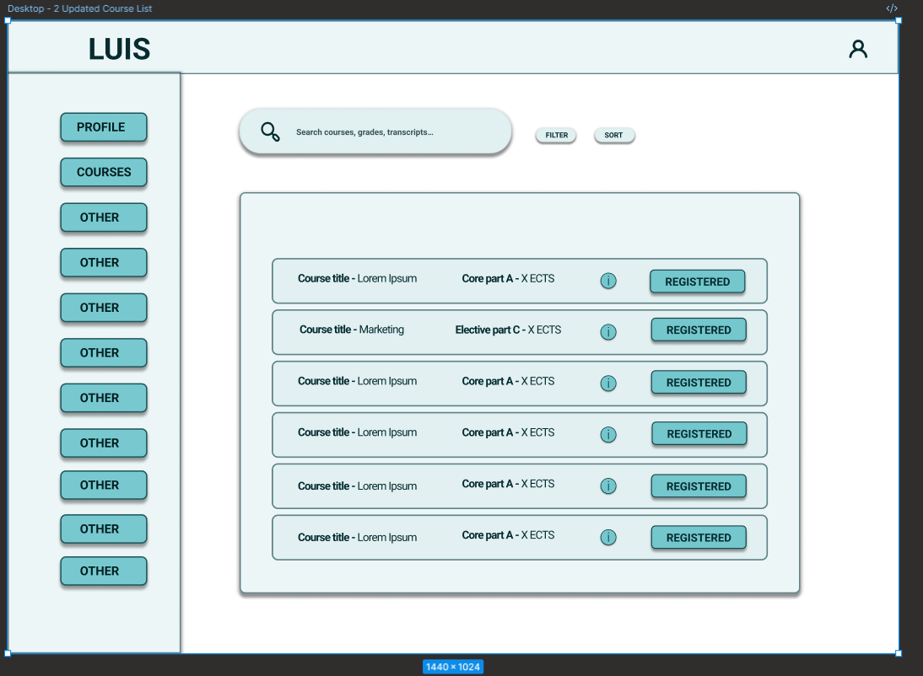

Figure 3.6. Student Desktop Wireframe - Courses

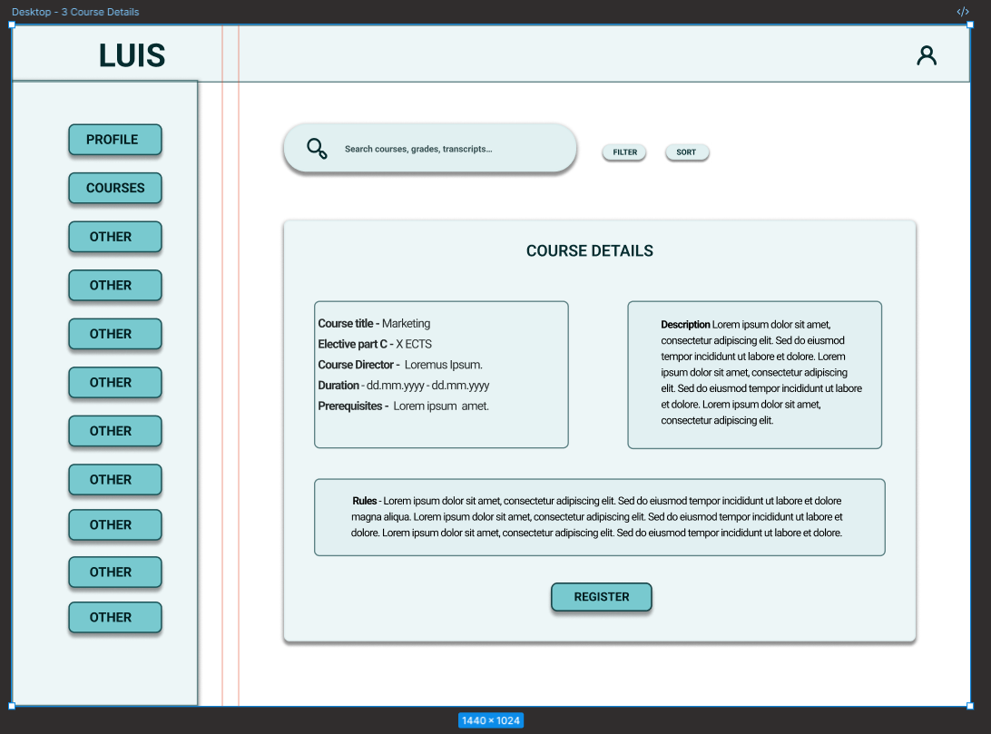

Figure 3.8. Student Desktop Wireframe – Course Details

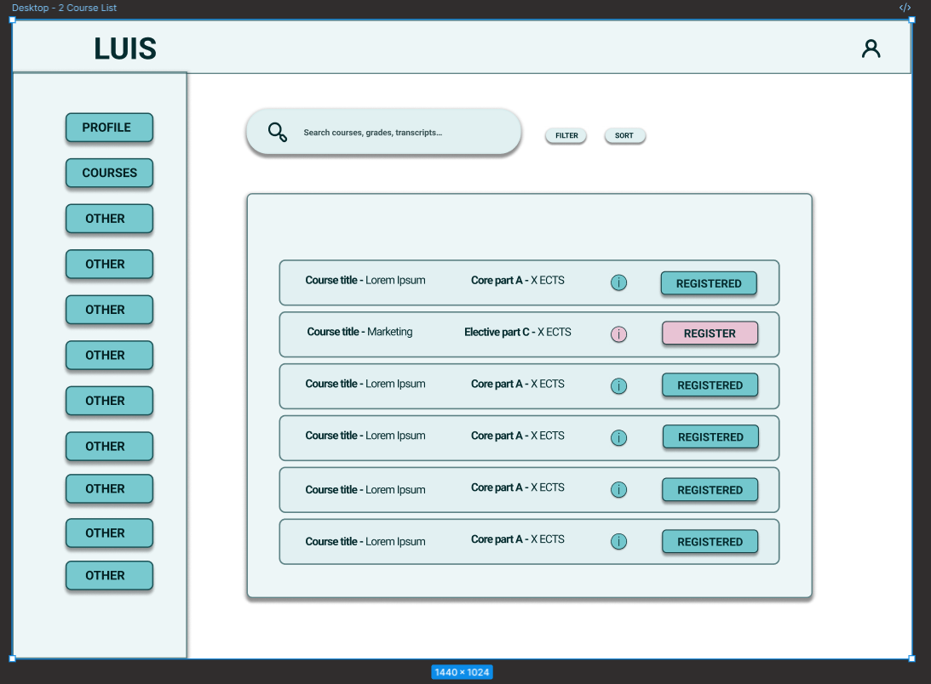

Figure 3.7. Student Desktop Wireframe - Courses

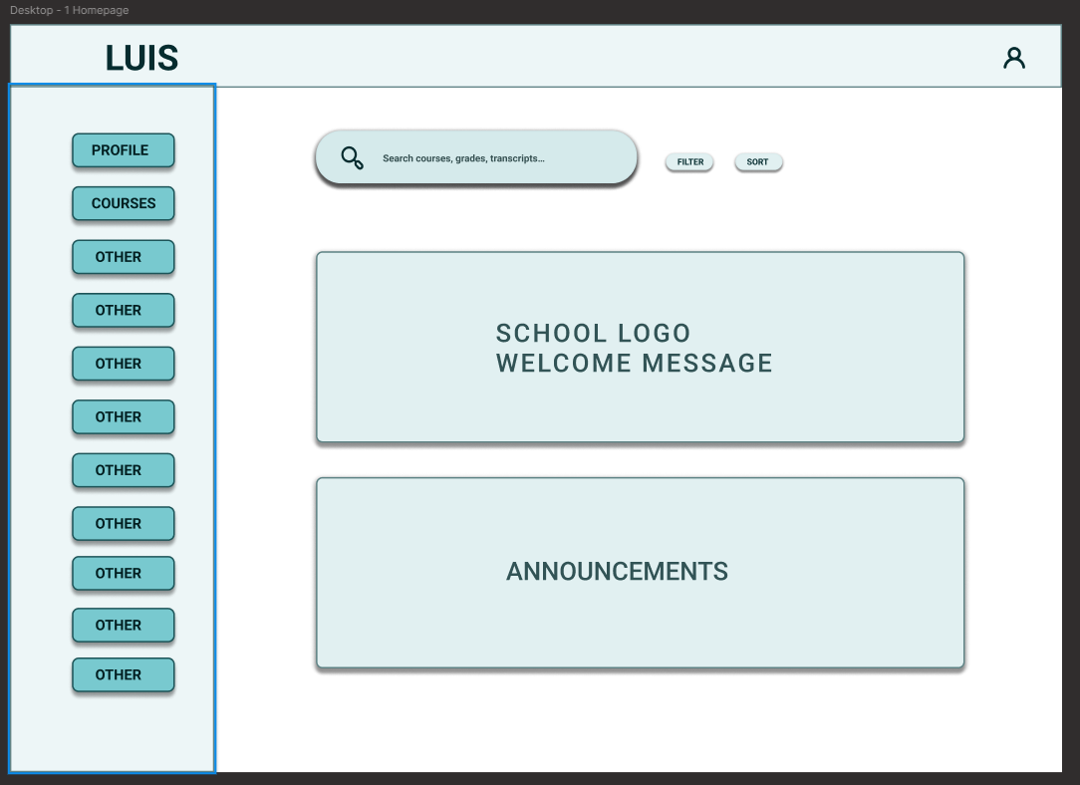

Figure 3.9. Student Desktop Wireframe – Homepage

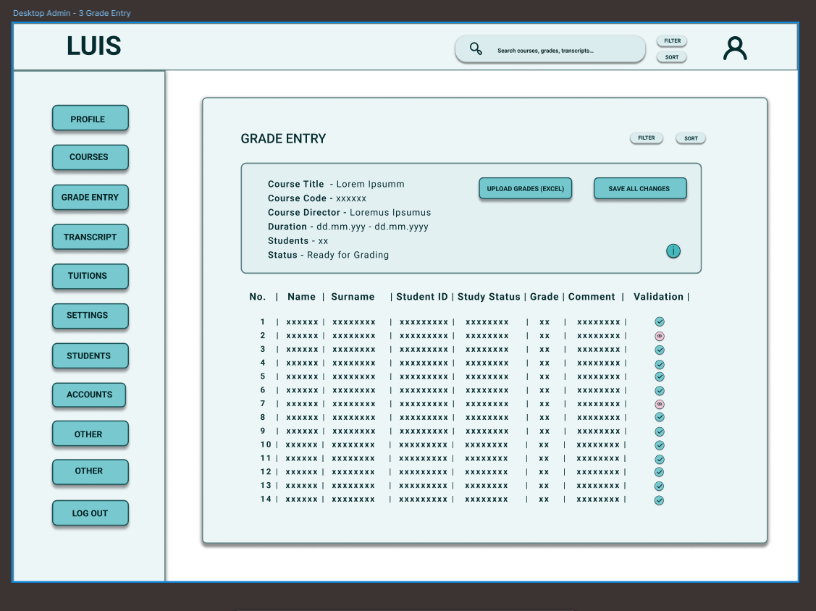

Figure 3.12. Admin Desktop Wireframe – Grade entry

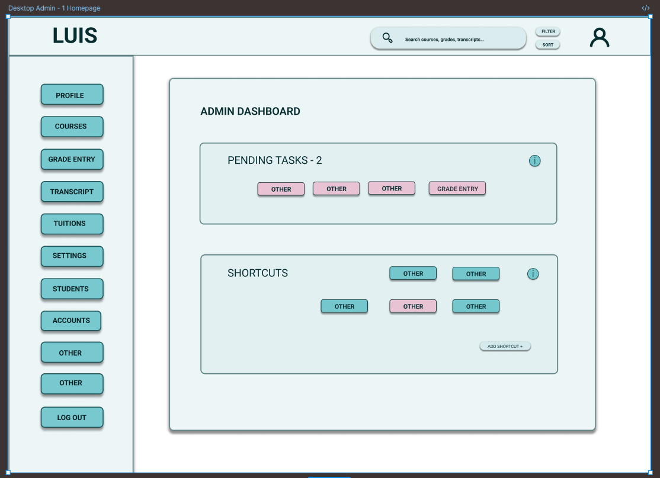

Figure 3.11. Admin Desktop Wireframe – Homepage

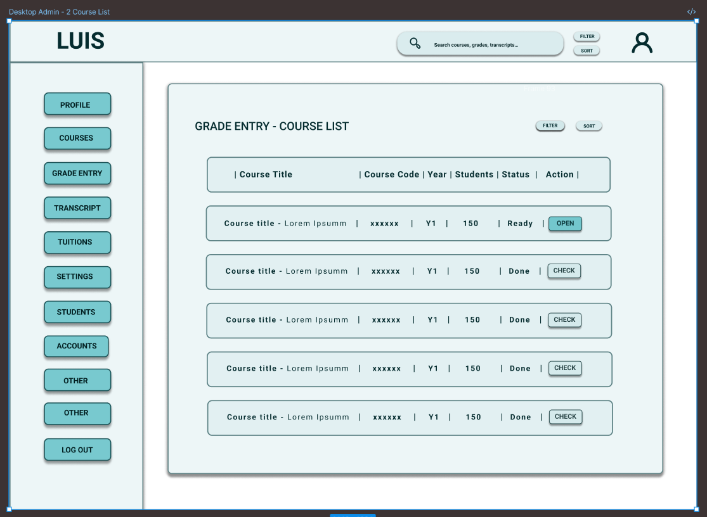

Figure 3.13. Admin Desktop Wireframe – Grade entry Detailed

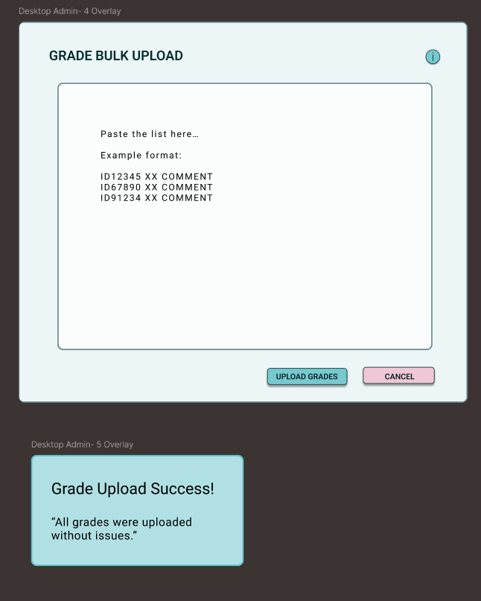

Figure 3.14. Admin Desktop Wireframe – Onscreen Pop-up grade upload.

| **Purpose** | **Colour name** | **Hex** | **Notes** |
| --- | --- | --- | --- |
| Primary structural background | Dark Navy | #011140 | Headers, navigation, strong structural blocks; high contrast. |
| Secondary structural background | Deep Navy | #010A26 | Top bars, secondary navigation, cards with stronger emphasis. |
| Main interactive / focus accent | Soft Blue | #4E74A6 | Icons, focus states, highlights for active items. |
| Neutral content background | Soft Beige | #F2E6DF | Main reading area behind text; low visual load. |
| Primary action accent | Muted Rose | #A67C7C | Main buttons such as **Register** and **Save**. |
| Secondary accent (status / highlights) | Soft Lilac | #AD71AE | Secondary emphasis, subtle status badges, supporting charts or tags. |

Table 3.x. Style Guide color codes.

Figure 3.18.- Student Desktop workflow prototype wiring.

Figure 3.19.- Admin Desktop workflow prototype wiring.

* Table caption above the table
* Figure caption below the figure
* Times New Roman 12
* Bold word “Figure 1.” / “Table 1.”

Custom styles:

**FigureCaption**  
**Table Caption**

Appendix 5 – LUIS- Existing State Visuals

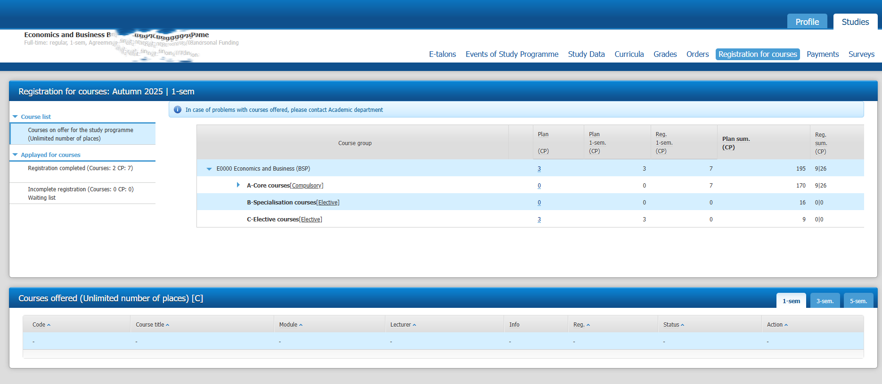Figure 3.3. Desktop course registration screen – unclear structure

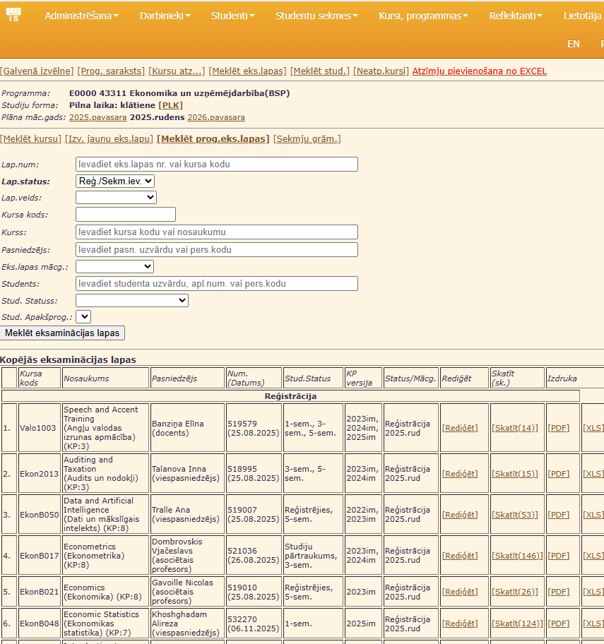

Figure 3.2.

ABBREVIATIONS

AI – artificial intelligence

ANN – artificial neural network

LLM – large language model

MLA – machine learning algorithm

DH - Digital Humanities

UX – User Experience

UI – User Interface

IA – Information Architecture

LUIS- The Latvian Academic Information System

VIIS - State Education Information System

CLT – Cognitive Load Theory